HSIE Semester 1

# The Main Causes of Migration from 1750 to 1901

The period from 1750 to 1901 saw an unprecedented increase in the number of people moving around the world – a process known as migration. Some people moved within their own countries (e.g. from rural areas to urban areas) while others moved between countries (e.g. from England to new colonies in North America and Australia).

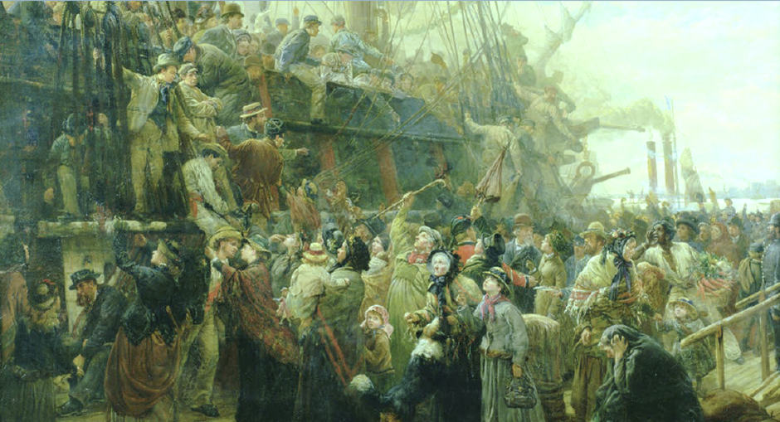

Source 1 The Emigrant Ship, a painting by Charles J Staniland, c. 1880, shows a ship docked in Liverpool, England, with emigrants to the New World on board being waved off by friends and relatives.

There were many reasons why people moved. Historians try to understand the different reasons for migration by organising them into four main categories:

* **economic migration** – moving in search of work. During the Industrial Revolution, mass migration took place as people moved from the countryside to growing towns and cities across England searching for work in factories and mines there. Later, once gold had been discovered in British colonies in Australia, thousands migrated in search of wealth.
* **social migration** – moving for a better quality of life or to be closer to family and friends. With steady work came an improved standard of living. Many people believed that industrial cities offered opportunities for a better life. Others believed that a fresh start in a far-off land offered these opportunities.
* **political migration** – moving to escape political persecution or war. A large number of people who moved from England to other parts of the world during the 18th and 19th centuries were political prisoners or radical thinkers who had criticised the monarch of England or challenged the authority of the government. These people were transported by force or fled persecution of their own accord.
* **environmental migration** – moving to escape natural disasters such as flooding and famine. In Ireland between 1845 and 1852, a period known as the Great Famine (or Irish Potato Famine) led to more than one million Irish men, women and children leaving their homeland in search of a safer environment in which to rebuild their lives.

As well as grouping migrants, historians also consider a range of other factors that influence people’s decisions. These are known as push factors and pull factors. Push factors are negative things that tend to push people away from certain places, whereas pull factors are positive things that pull people towards a certain place. Some examples of push factors include poverty, famine, crop failure, lack of employment, overcrowding, natural disasters, war, and political or religious oppression. Some examples of pull factors include better job opportunities, more space and greater religious and political freedoms.

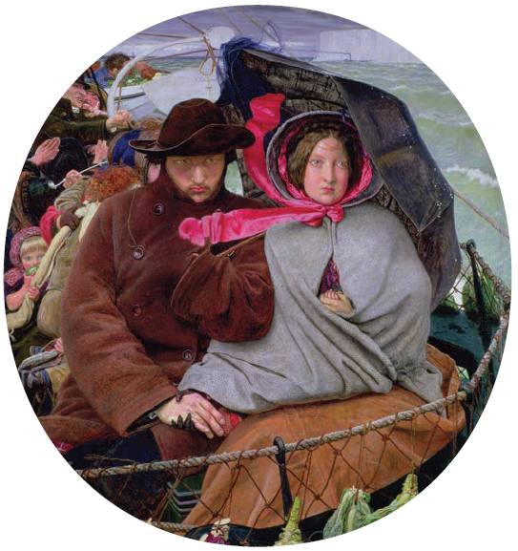

|543x577

Source 2 The Last of England, a painting by Ford Maddox Brown, 1852–55, shows a couple emigrating with their baby in a ship named Eldorado, with the white cliffs of Dover (a city in southern England) in the background.

## Defining Migration and Understanding Different Types of Migrants

Before learning about the events of the period, it is important to define some key terms and groups of people. These terms are used frequently throughout this chapter, so refer back to this list whenever you need to. They include:

* **emigration**: the departure of people from their homeland (country of birth) to settle permanently in a new country
* **immigration**: the arrival of people into a new country to settle permanently
* **migration**: the movement of people within a country or from one country to another
* **convict**: a person found guilty or a crime and sentenced to punishment by a court; convicts in Britain during the 18th century were often transported to serve a sentence in British colonies such as Australia
* **slave**: a person who is considered to be the property of another person and has very few (if any) rights; during the 18th century, many Africans were enslaved by Europeans and taken by force to the Americas
* **free settler**: a person who pays their way and chooses to settle in a new country
* **assisted migrant**: a person who receives assistance from a government or organisation to move to another country.

When learning about the movement of peoples during this period, we need to consider the perspectives of the various people involved. For example, the perspectives and experiences of slaves and convicts will be very different to the perspectives and experiences of free settlers. The perspectives of these different people will have influenced how they viewed or reacted to specific events at the time. They will also have influenced the ways in which people recorded and wrote about their experiences. It is always important to consider the impact that a particular perspective will have on a source.

## Push Factors

Since the beginning of the Industrial Revolution in 1750, many factors have pushed people towards starting a new life elsewhere. A range of these factors is discussed below.

### The Agricultural Revolution

Until the early 18th century, most people in Europe lived in rural areas and worked in agriculture. Land use had changed little since the Middle Ages, and families often worked the same land for generations. Most peasants worked enough to provide food to feed their families. Their lives were simple and there was a certainty about their roles as members of village communities.

All of this changed with the development of new farming techniques and agricultural machines during the 18th century. The Agricultural Revolution began in Britain but quickly spread to Western Europe. New methods of crop rotation and animal breeding – as well as the invention of machines for ploughing, sowing seed and harvesting – improved crop yields and quality of meat (see Source 3).

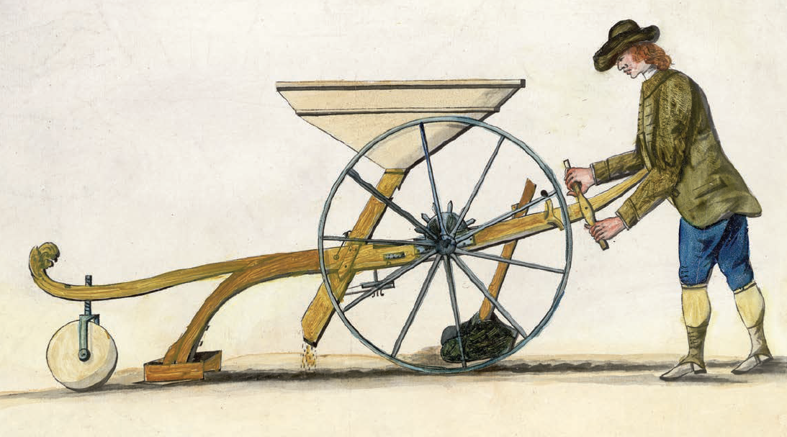

Source 3 The seed drill invented by Jethro Tull made the sowing of crops easier and involved far less waste of seed. It also required fewer labourers.

These new approaches to farming were beneficial for the landowners, but forced many peasants off the lands that their ancestors had farmed. Wealthy landowners enclosed fields for planting and grazing. They still required peasants to look after the crops and animals, but the new machines meant fewer labourers were needed. This was the first major example of technology claiming jobs.

The Agricultural Revolution resulted in a wave of migration from the country to newly emerging towns and cities. Many who had lost their livelihoods in villages, especially the young and single, flocked to the towns and cities looking for work. This migration coincided with the Industrial Revolution.

### The Industrial Revolution

At the same time as new methods and machines were modernising agriculture, new approaches to manufacturing and food processing were emerging. The steam engine paved the way for the development of machines such as the locomotive, spinning and weaving machines, pumps to assist mining, and smelters to process the ores.

A vast unskilled or semi-skilled labour force was required to support this new industrial economy. Working conditions were terrible and there were also no laws banning child labour. As a result, children as young as six were put to work in the mines and factories (see Source 4). Their size made them valuable to employers because they could fit into small spaces and climb under machines. They often worked in great danger for very little money.

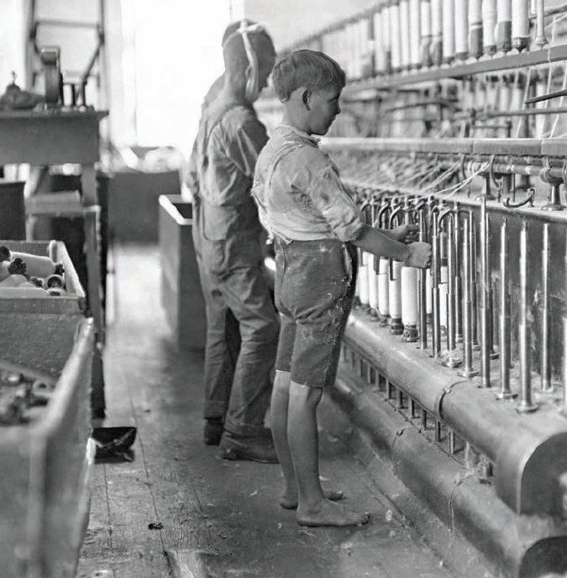

Source 4 Children were often forced to work in factories during the Industrial Revolution. This was a push factor for some families to emigrate.

The great migration of people into towns and cities across England provided the labour force for the new factories. English cities such as Manchester, Liverpool and Birmingham grew rapidly. This resulted in overcrowding and unhealthy living conditions. For many of the poor in these industrial cities, as well as the displaced in rural areas, migrating to new countries in search of a better life provided a way out. A great increase in crime, plus overcrowded jails, contributed to another of the major push factors behind emigration from Britain in the 18th and 19th centuries – the transportation of convicts to penal colonies in North America and Australia.

### Population Growth

During the 18th century, improvements in food production and new discoveries in medicine and hygiene led to a significant increase in population. The birth rate was rising, fewer children were dying and adults, on average, were living longer. Between 1750 and 1800, the population of Britain grew from 6.5 million to 9 million. This population growth created great pressures, especially at a time when new technology on farms and in factories was reducing the number of available jobs. Emigration provided a kind of safety valve in reducing pressure on jobs, housing and resources.

### Natural Disasters: the Irish Potato Famine

Over the centuries, natural disasters have also been push factors motivating groups of people to leave their homelands in order to survive. One such natural disaster took place in Ireland in the middle of the 19th century. It resulted in one of the greatest movements of people from a single, country, and occurred as a result of the failure of the potato crop in Ireland.

At the time of the famine, most Irish farmers rented the farming lands on which they lived and worked from wealthy English lords. The majority of crops and animals that the Irish farmers produced on these lands were paid as rent, leaving most peasant families to rely heavily on the potato crop in order to survive. In the 1840s, the potato crop failed several years in a row because of poor soil and a disease called potato blight that made the potatoes inedible. Most landowners refused to waive the rents, which would have enabled the Irish farmers to survive this tragedy.

The result was starvation in Ireland while tonnes of edible crops (paid in rent) were shipped to England. Those who were evicted from their cottages for non-payment of rent often finished up in workhouses where they received only the most basic accommodation and food. Disease was widespread in most workhouses, and the already starving and weakened peasants had little resistance. The most disastrous years of famine were from 1847 to 1849. The famine, which became known as the Great Famine, caused between 1 and 1.5 million deaths and resulted in up to two million people leaving Ireland in search of a better life.

Over the ten years of the Great Famine, the population of Ireland decreased by one-third. A small percentage of those who left Ireland travelled to Australia and New Zealand, but most went to North America because the journey was shorter and cheaper. However, it is estimated that up to one in five emigrants died making the voyage. As a result, the ships they travelled on became known as ‘coffin ships’. Poor sanitation, overcrowding, lack of food and disease meant that many passengers, already weakened by starvation, were not able to survive the journey.

### Discrimination and Persecution

Over the centuries, many waves of emigrants have also left their homelands to escape religious or political persecution. Certain American colonies, for example, were established by Puritans (a group of English Protestants who believed in strict religious discipline) escaping religious persecution in Britain.

Jewish people had suffered discrimination in Europe for centuries and emigrated to escape persecution. They often became scapegoats when times were tough, because some Jews appeared to be more wealthy and successful than other groups in society. However, this perception was often untrue. Many Jewish people, especially in Eastern Europe, were not allowed to own land and were among the poorest peasants. During the 19th century there were organised attacks on Jews (see Source 5). This led to many Jews fleeing to countries like the USA.

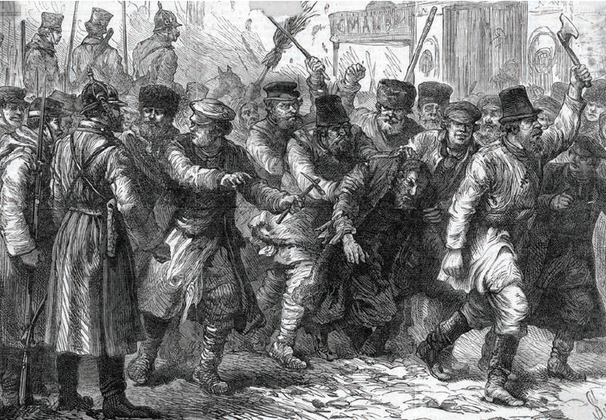

Source 5 A 19th-century engraving showing an attack on Jewish citizens in Kiev, Ukraine

### Forced Migration

Not all people who left their homelands during this period of history did so willingly. In fact, the largest number of migrants at this time were forced to move. These groups included slaves and convicts.

From the early 17th century, hundreds of thousands of African people were captured and transported across the Atlantic to America as slaves (see Source 6). This meant they were taken prisoner and then sold as goods. The purpose of this scheme was to provide a free labour force in the North American colonies.

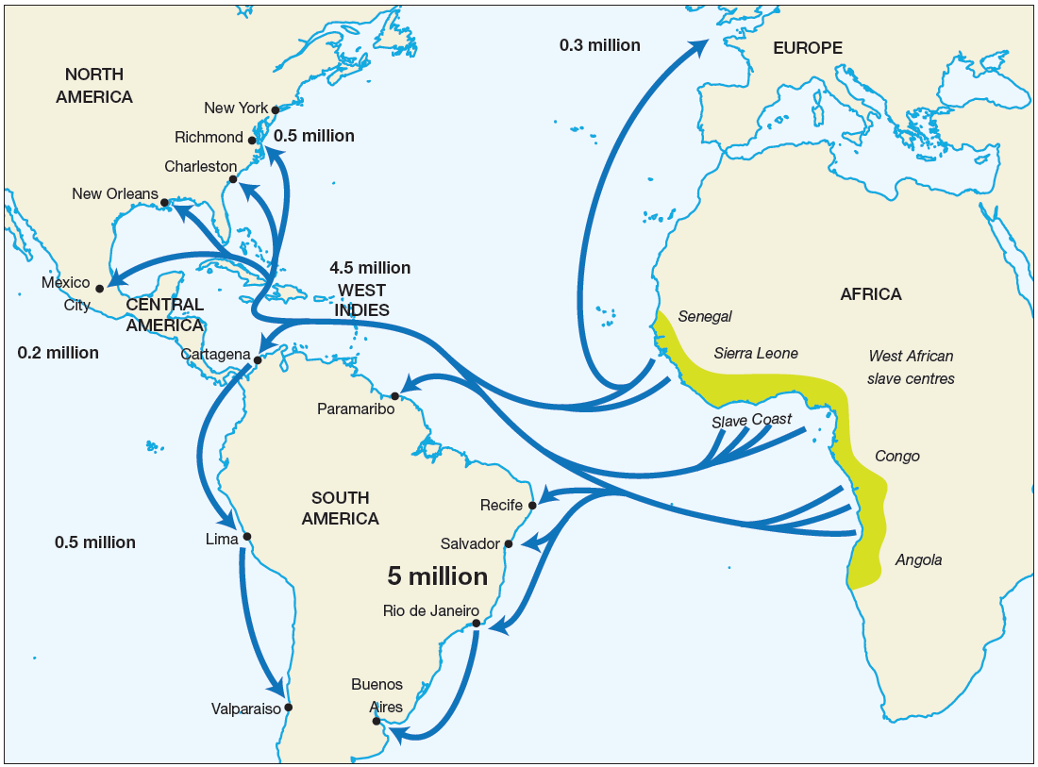

Source 6 World slave routes

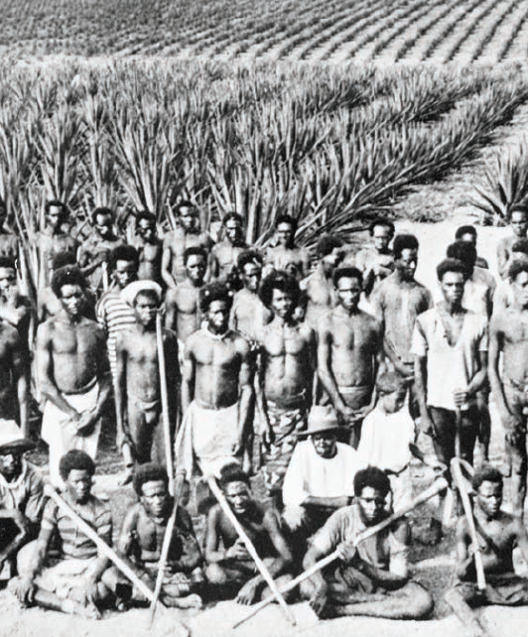

A smaller scheme also involved the capture of people from islands across the Pacific and the transfer of these people to Queensland from the 1860s. These people, who became known as South Sea Islanders, were used as cheap labour on Queensland sugar cane and pineapple plantations (see Source 7).

Source 7 South Sea Islanders on a Queensland pineapple plantation in the 1890s

In addition to the forced migration of slaves, between 1788 and 1868 over 165 000 convicted British criminals – many guilty of only minor crimes – were transported across the world to the Australian colonies. Although these people were forced migrants, great opportunities were offered to those convicts who worked hard and did not reoffend. After their release, many ex-convicts in Australia reflected that transportation had eventually provided a better way of life than they could ever have hoped for in Britain. Only a small percentage of convicts returned to Britain when they had completed their sentences.

Source: Oxford Insight History, Stage 5, 2nd edition, 2021

## Pull Factors

Some pull factors that encouraged people to migrate during this period included things like the promise of a better life, better employment opportunities, more space, more fertile soil, greater personal freedom and the opportunity to shape the future of an undeveloped land.

Between 1750 and 1901, millions of people were pulled towards particular destinations as a result of a range of these factors. North America and Australia offered stability, democracy and a future. The discovery of gold in both regions during this period also led to a dramatic increase in the population.

During the 18th and 19th centuries, North America, Australia, New Zealand and South Africa offered abundant land that many Europeans saw as theirs for the taking. In some cases, free grants of land were made to attract new settlers. Even when land was not free, prices were usually low and it was relatively easy for newcomers to set up small farms and build new lives. This pull factor, along with a range of other factors, is discussed below in relation to North America and the Australian colonies.

### North America

From 1775 to 1783, thirteen colonies in North America fought a War of Independence to break free from British control. After winning their independence, a period of growth and expansion began and the country we now think of as the United States of America began to take shape. As people moved west across the country, new settlements and trade routes developed, creating employment and opportunities to own land.

By the late 19th century, other British colonies and settlements across Canada were also starting to expand. Like the USA, Canada had large areas of land available. To encourage development, land was given free to settlers along the route of the Canadian Pacific Railway – a railway line built during the 1880s connecting the east coast of Canada with the west coast.

In 1848, gold was discovered in California. This led to a gold rush that brought around 300 000 people to California over the next five years, transforming the area. This was followed by a Colorado gold rush that led to the development of the area inland from California. Over time, the goal of developing the USA as a land of opportunity that stretched from the Atlantic Ocean in the east to the Pacific Ocean in the west was achieved.

The idea of ‘America’ as a prosperous democracy was a powerful pull factor for the many Europeans who had seen their lives worsen as a result of the Industrial Revolution.

### Idaho Springs

In 1859, gold was discovered in Idaho Springs in Colorado, USA. This began the Colorado gold rush that followed the one in California. Like many areas, Idaho Springs was transformed by the sudden influx of goldminers and the support industries necessary to provide them with goods and services such as tools, meals and accommodation.

It is important to see how both the California and Colorado gold rushes transformed different areas, but it is also just as important to look how these areas stayed the same over time. Sources 1 and 2 are photographs taken over 100 years apart. As a historian, it is important that you train yourself to look for obvious changes, but also take the time to explore continuities. Continuities are often more difficult to recognise, but they are also important in historical study. For example, although the methods of transportation in Idaho Springs have changed, the basic layout of the town and a number of its buildings remain unchanged.

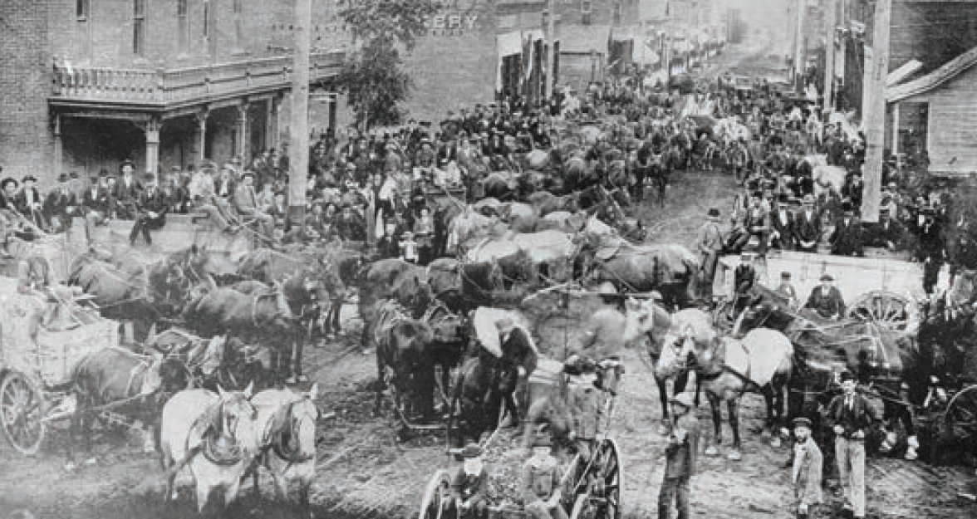

Source 1 A 19th-century street scene in Idaho Springs, Colorado, as goldminers flock to the area.

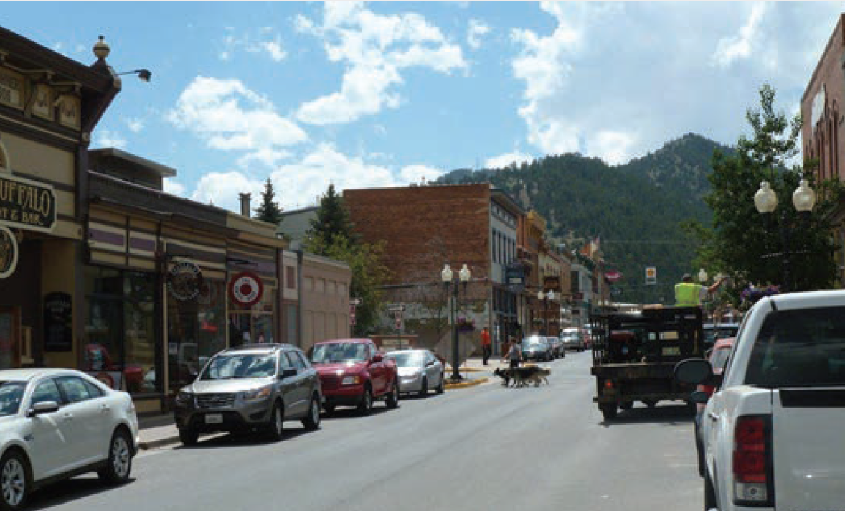

Source 2 The same street in Idaho Springs in 2011

### Australia

When the First Fleet arrived in Australia to establish a British colony in 1788, they were carrying around 750 convicts, soldiers and government officials with them. This was the first British population of Australia. Life was difficult in such a different climate, but gradually the first colony expanded. By the 19th century there were also colonies in Queensland, Victoria, Tasmania, South Australia and Western Australia.

As exploration opened the continent to settlement, the need for workers increased. Convicts were gradually replaced by free settlers and a new class of assisted migrants (people who were given financial assistance from the government to encourage them to move to Australia).

If workers in Britain possessed a particular skill, employers in Australia could apply for financial assistance to bring them over to settle and work here. Magazines often featured cartoons comparing life in England with life in the colonies (see Source 3). This kind of assisted migration continued throughout the 20th century and was an important way of boosting the number of immigrants arriving in Australia.

The discovery of gold helped transform Australia. Gold was first discovered in New South Wales in 1851. Between 1850 and 1860 the population of Australia more than doubled. In addition to the thousands who arrived in search of wealth on the goldfields (see Source 4) were groups of political refugees (known as Chartists), activists and religious orders. These groups believed there was greater opportunity to think and speak freely, express differing political views and practise one’s chosen religion in Australia.

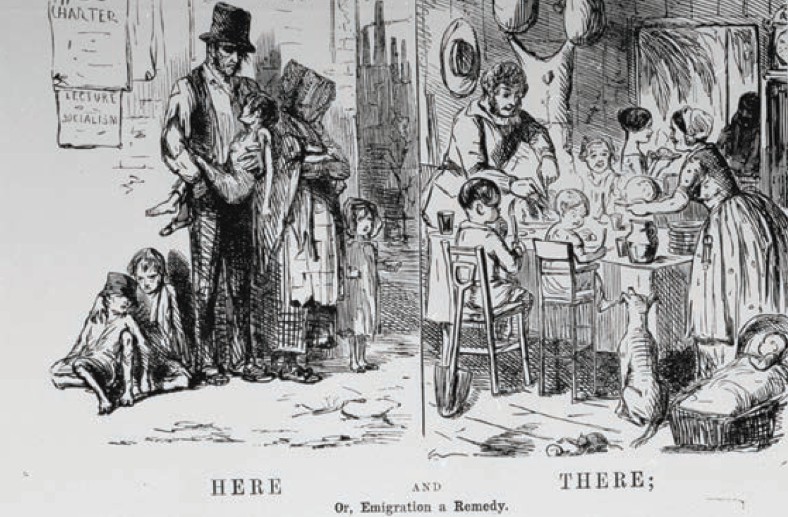

Source 3 One of many posters used in Britain during the 19th century to encourage people to emigrate to British colonies such as those in Australia.

Source 4 This painting by ST Gill from 1869 titled Digger’s Wedding shows a newly wealthy goldminer enjoying a drunken carriage ride. At the time, the upper classes feared wealthy miners with no social standing as a serious threat to their position and authority in society. (The subtitle of the painting is The Dangers of Horrid Democracy.)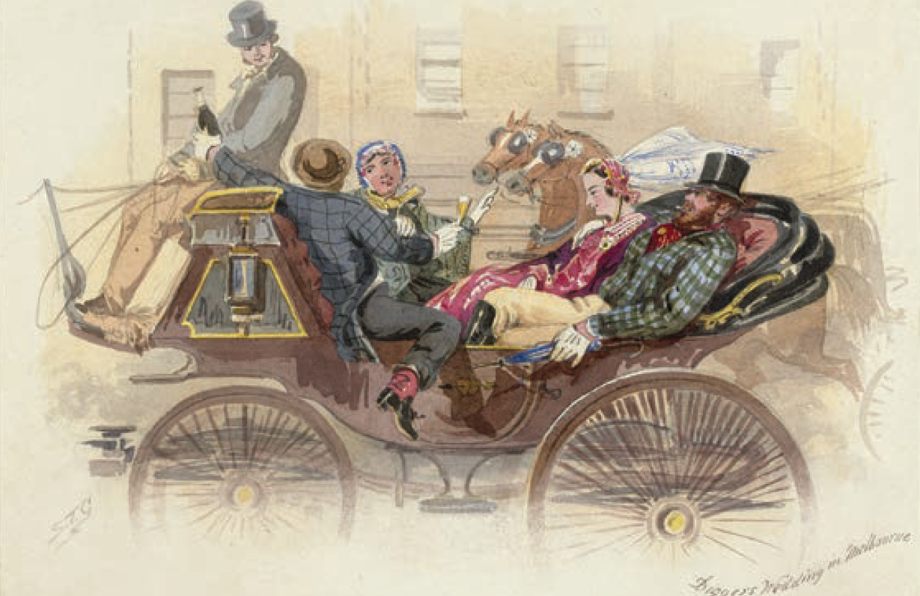

# Agricultural Revolution - Enclosure

In English History, enclosure was the process which ended the traditional right of all people to use common land to grow crops or raise livestock.

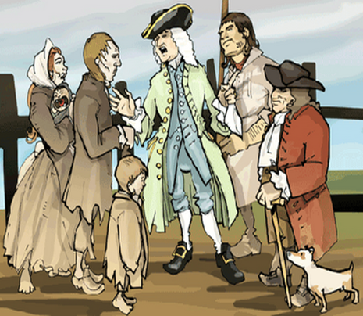

Traditionally large sections of land were common land, which allowed people to grow enough (on that land) to survive on and raise their families, without a paid job. This is known as subsistence farming.

The process of enclosure restricted use of land to the owner/s, barring all others from using it. This process started around the 1500s and saw the countryside divided up into a patchwork of fields and paddocks, separated by fences made of stone or hedges.

By the 1800s, most common land in England had been put into private hands. In many cases, the rich used their power to force poor families off the land they inhabited legally for generations, leaving them homeless.

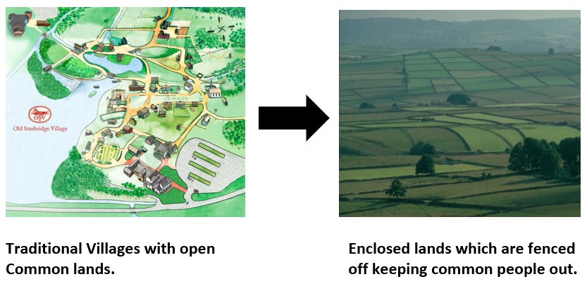

## Contestability

One perspective on the process of enclosure is that enclosure was sometimes accompanied by force, resistance, and bloodshed, and remains among the most controversial areas of agricultural and economic history in England. Marxist and neo-Marxist historians argue that rich landowners used their control of state processes to appropriate public land for their private benefit. This created a landless working class that provided the labour required in the new industries developing in the north of England.

For example, one Marxist view was: “In agriculture the years between 1760 and 1820 are the years of wholesale enclosure in which, in village after village, common rights are lost. Enclosure (when all the sophistications are allowed for) was a plain enough case of class robbery”.

Alternately, W. A. Armstrong argued that this is perhaps an oversimplification, that the better-off members of the European peasantry encouraged and participated actively in enclosure, seeking to end the perpetual poverty of subsistence farming. He stated, “we should be careful not to ascribe to [enclosure] developments that were the consequence of a much broader and more complex process of historical change. The impact of the eighteenth and nineteenth century enclosure has been grossly exaggerated….”

## People Move to New Industrial Cities

The Industrial Revolution brought rapid urbanization, or the movement of people to cities. Changes in farming, soaring population growth, and an ever-increasing demand for workers led masses of people to migrate from farms to cities. Almost overnight, small towns around coal or iron mines mushroomed into cities.

Other cities grew up around the factories that entrepreneurs built in once-quiet market towns. The British market town of Manchester numbered 17,000 people in the 1750s. Within a few years, it exploded into a centre of the textile industry. Its population soared to 40,000 by 1780 and 70,000 by 1801. Visitors described the “cloud of coal vapour” that polluted the air, the pounding noise of steam engines, and the filthy stench of its river.

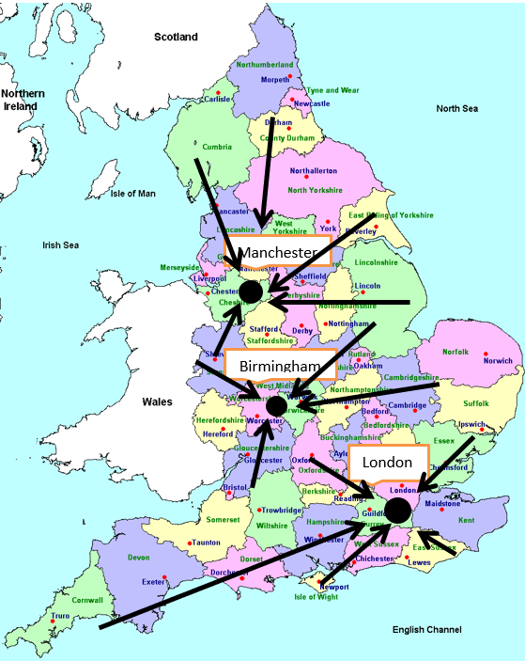

As enclosure locked people off their land, they were forced to move to the big industrial cities looking for work

# Why Did the Industrial Revolution Begin in Great Britain

The Industrial Revolution marked a period of development in the latter half of the 18th century that transformed largely rural, agrarian societies in Europe and America into industrialised, urban ones. Goods that had once been painstakingly crafted by hand started to be produced in mass quantities by machines in factories, thanks to the introduction of new machines and techniques in textiles, iron making and other industries.

Fuelled by the game-changing use of steam power, the Industrial Revolution began in Britain and spread to the rest of the world, including the United States, by the 1830s and ‘40s. Modern historians often refer to this period as the First Industrial Revolution, to set it apart from a second period of industrialisation that took place from the late 19th to early 20th centuries and saw rapid advances in the steel, electric and automobile industries.

## England: Birthplace of the Industrial Revolution

Thanks in part to its damp climate, ideal for raising sheep, Britain had a long history of producing textiles like wool, linen and cotton. But prior to the Industrial Revolution, the British textile business was a true “cottage industry,” with the work performed in small workshops or even homes by individual spinners, weavers and dyers.

Starting in the mid-18th century, innovations like the flying shuttle, the spinning jenny, the water frame and the power loom made weaving cloth and spinning yarn and thread much easier. Producing cloth became faster and required less time and far less human labor.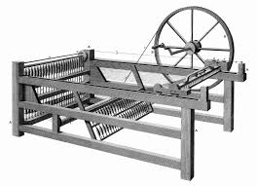

More efficient, mechanised production meant Britain’s new textile factories could meet the growing demand for cloth both at home and abroad, where the nation’s many overseas colonies provided a captive market for its goods. In addition to textiles, the British iron industry also adopted new innovations. Chief among the new techniques was the smelting of iron ore with coal (a material made by heating coal) instead of the traditional charcoal. This method was both cheaper and produced higher-quality material, enabling Britain’s iron and steel production to expand in response to demand created by the Napoleonic Wars (1803-15) and the later growth of the railway industry.

## Impact of Steam Power

An icon of the Industrial Revolution broke onto the scene in the early 1700s, when Thomas Newcomen designed the prototype for the first modern steam engine. Called the “atmospheric steam engine,” Newcomen’s invention was originally applied to power the machines used to pump water out of mine shafts.

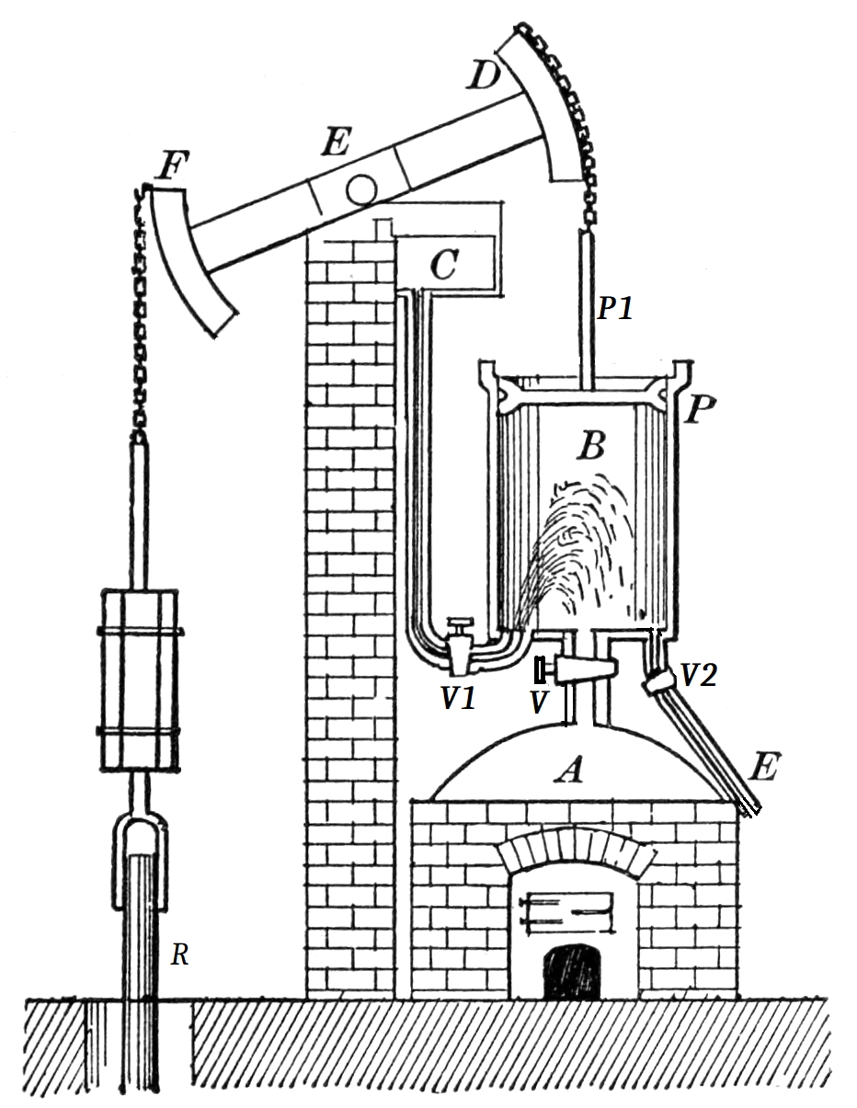

|315x407

In the 1760s, Scottish engineer James Watt began tinkering with one of Newcomen’s models, adding a separate water condenser that made it far more efficient. Watt later collaborated with Matthew Boulton to invent a steam engine with a rotary motion, a key innovation that would allow steam power to spread across British industries, including flour, paper, and cotton mills, iron works, distilleries, waterworks and canals.

Just as steam engines needed coal, steam power allowed miners to go deeper and extract more of this relatively cheap energy source. The demand for coal skyrocketed throughout the Industrial Revolution and beyond, as it would be needed to run not only the factories used to produce manufactured goods, but also the railroads and steamships used for transporting them.

## Transportation During the Industrial Revolution

### Evolution of Railways

Britain’s road network, which had been relatively primitive prior to industrialisation, soon saw substantial improvements, and more than 2,000 miles of canals were in use across Britain by 1815. In the early 1800s, Richard Trevithick debuted a steam-powered locomotive, and in 1830 similar locomotives started transporting freight (and passengers) between the industrial hubs of Manchester and Liverpool. By that time, steam-powered boats and ships were already in wide use, carrying goods along Britain’s rivers and canals as well as across the Atlantic.

## Communication and Banking in the Industrial Revolution

The latter part of the Industrial Revolution also saw key advances in communication methods, as people increasingly saw the need to communicate efficiently over long distances. In 1837, British inventors William Cooke and Charles Wheatstone patented the first commercial telegraphy system, even as Samuel Morse and other inventors worked on their own versions in the United States. Cooke and Wheatstone’s system would be used for railroad signalling, as the speed of the new trains had created a need for more sophisticated means of communication.

Banks and industrial financiers rose to new prominence during the period, as well as a factory system dependent on owners and managers. A stock exchange was established in London in the 1770s; the New York Stock Exchange was founded in the early 1790s.

In 1776, Scottish social philosopher Adam Smith (1723-1790) promoted an economic system based on free enterprise, the private ownership of means of production, and lack of government interference.

## Working Conditions

Though many people in Britain had begun moving to the cities from rural areas before the Industrial Revolution, this process accelerated dramatically with industrialisation, as the rise of large factories turned smaller towns into major cities over the span of decades. This rapid urbanisation brought significant challenges, as overcrowded cities suffered from pollution, inadequate sanitation and a lack of clean drinking water.

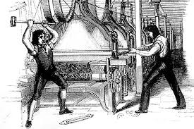

Meanwhile, even as industrialisation increased economic output overall and improved the standard of living for the middle and upper classes, poor and working class people continued to struggle. The mechanisation of labour created by technological innovation had made working in factories increasingly tedious (and sometimes dangerous), and many workers were forced to work long hours for pitifully low wages. Such dramatic changes fuelled opposition to industrialisation, including the “Luddites,” known for their violent resistance to changes in Britain’s textile industry.

In the decades to come, outrage over substandard working and living conditions would fuel the formation of labor unions, as well as the passage of new child labor laws and public health regulations in both Britain and the United States, all aimed at improving life for working class and poor citizens who had been negatively impacted by industrialisation.

Source: <https://www.history.com/topics/industrial-revolution/industrial-revolution>

## Why Did the Industrial Revolution Start in Great Britain in the 1750s?

Many factors played a part in the development of the industrial revolution in Great Britain. The seeds were sown, quite literally, thanks to the agricultural revolution that enabled the production of food surplus and population growth.

Almost simultaneously, any excess in labour was attracted to larger population centres in search of work and fortune. Institutions like the banks of the time could provide capital (money) to brave entrepreneurs to build new technologies and companies that might not otherwise be able to afford to. Importantly, the rule of property rights also promoted investment and risk-taking. Large structures like factories could now be built on credit.

The granting of patents (the legal right to own the design of a machine) was now turned into a formalised and legally binding system. This further created confidence for investors and inventors to take a gamble.

Britain also happened to have a wealth of coal, iron, and other resources in a relatively small country, that would help kick start the revolution and feed it. It’s small, but growing Colonial Empire also provided a ready-made market for surplus goods, providing further impetus to entrepreneurs and new industrialists.

Initial developments occurred in the cotton industry with the development of the spinning jenny, flying shuttle and power loom, and very soon, other industries would benefit from industrialisation.

Source: <https://interestingengineering.com/why-did-the-industrial-revolution-start-in-britain>

# The Industrial Revolution Nature and Significance

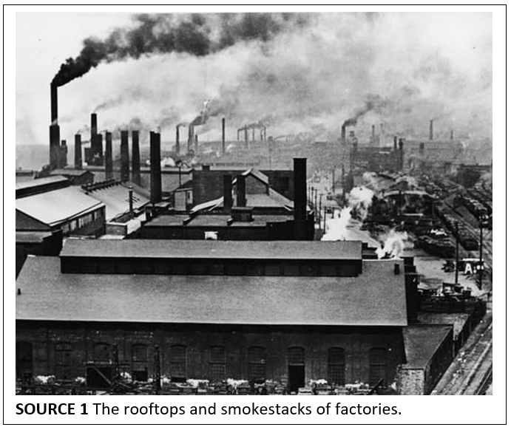

The Industrial Revolution is the name given to the great changes that began in Britain in the eighteenth century. These changes altered the way in which goods were made, and the way that people lived. The task of making goods was taken out of small homes and villages and placed into large new centres of manufacturing where people, materials and technology were gathered.

Historians regard industrialisation as the biggest change in human history since the coming of the wheel, or the development of agriculture. Like these earlier revolutionary changes, the Industrial Revolution did not begin suddenly, but occurred over a long period of time.

## Australian Manufacturing for the Masses

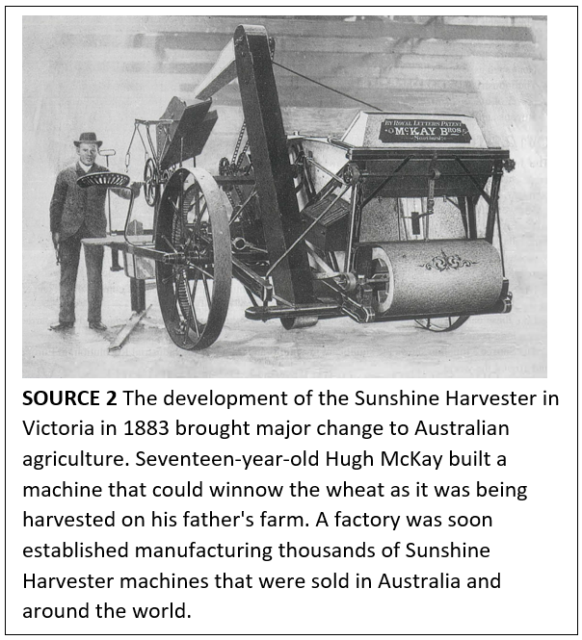

|0x0

The technology of the industrial revolution was quickly adopted in Britain’s most remote colony, New South Wales. Australia’s first steam-powered flour mill commenced operation in 1813 at Darling Harbour. Barker’s Mill ground wheat so efficiently that by 1826 their production levels required the construction of a five-storey high grain store and a large wharf to enable distribution of processed goods.

Transport and communication links became a priority as Australia’s agricultural industry developed. By 1830 steamships were regularly in use in New South Wales, followed by the construction of railway lines in the 1850s. As each of the Australian colonies embraced the new technology of overland telegraphs and developed railway systems, more Australian agricultural products and mass-produced goods were transported to the seaports and the expanding overseas markets.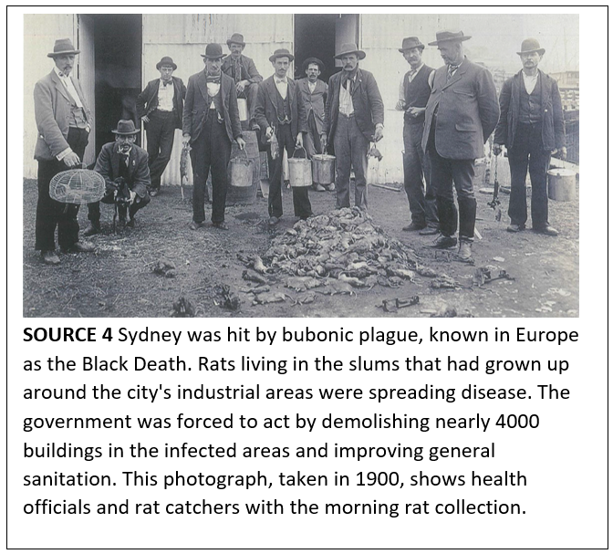

The 1851 discovery of gold was one of the most important events in Australia’s history. Technology to sink shafts, transport quartz and extract gold was urgently required. The need for mechanised transport increased and new engineering works were established. Australia’s economy grew rapidly, affecting every aspect of Australian life. Factories were built to supply a wealthier and larger population with a vastly expanded range of locally produced goods and services.

The Australian economy boomed during the 1880s. Mining dredges for the goldfields, lifts for city buildings, pumps for water sewerage systems and bricks for thousands of new houses were mass-produced in Australia’s factories. The power of technology and industry combined with population growth to transform a penal colony into a thriving new nation.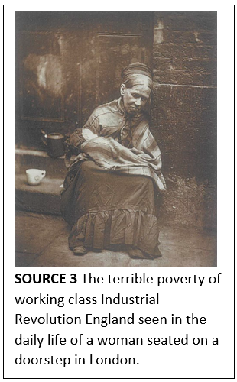

## From Revolution to Reform - Significance of the Industrial Revolution

The Industrial Revolution eventually changed the way that people lived all over the world.

* **Structure and organisation of society**: peasants from rural villages became workers living in the slums of industrial towns. The workers were known as the proletariat and the factory owners and managers were known as the bourgeoisie.
* **World population**: increased food production, gradual improvements to living conditions and medical advances led to the growth of the European population from 187 million in 1800 to over 400 million in 1900.
* **Role of governments**: The British Factory Act of 1883 and a range of other laws regulated the employment of children and generally improved working conditions in mines and factories.
* **Contact between regions and countries**: world trade and finance links stimulated economic growth.
* **New political ideas**: the educated middle classes demanded greater representation in government, along with political and personal rights.
* **Technology for warfare**: industrial power and military strength became more closely linked as much larger quantities of armaments were produced.

Source 4 - Timeline of significant inventions and events during the industrial revolution

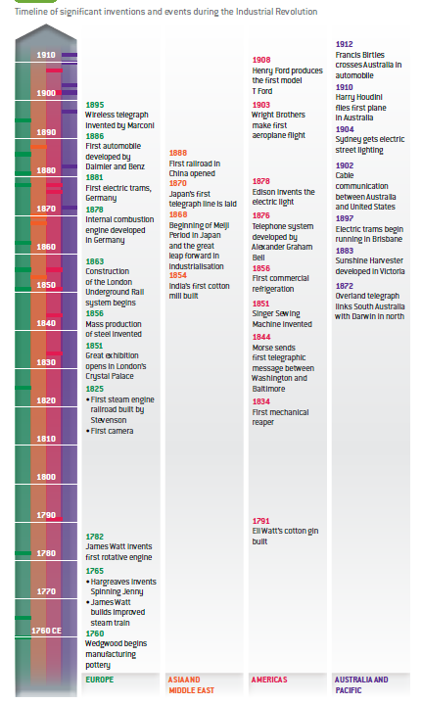

# Industrial Revolution Changing Ways of Life

The rapid growth of factories between 1800 and 1850 affected everybody’s lives. Life improved for mechanics - those who built and serviced the machines. They were paid well, and set up ‘mechanics institutes’ with their own libraries and held regular lectures there. They became part of a growing middle class.

However, for ordinary workers who had moved from the countryside or emigrated from Ireland and Scotland, working and living conditions were poor. Houses were crowded together, with little natural light and no sanitation. To keep the machines running in the factories, people had to work up to twelve-hour shifts. There was little protection from contact with moving machine parts and no compensation for injured workers.

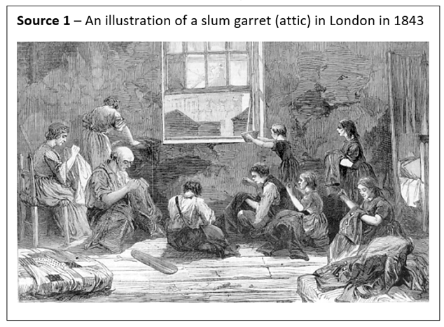

Friedrich Engels (1820-1895) was the son of a wealthy German industrialist. Sent to work in his father’s cotton mill in Manchester, Engels began to discover the reality of how working people lived, and in 1845 he published a book on the subject entitled Condition of the Working Class in England.

|  |
| --- |
| Source 2 - In his book, Condition of the Working Class in England, Engels quotes from a police report after two boys were arrested for stealing and eating a half-cooked calf’s foot.When a policeman went to his widowed mother’s house to investigate, he found her with six of her children literally huddled together in a little back room, with no furniture but two old rush-bottomed chairs with the seats gone, a small table with two legs broken, a broken cup, and a small dish. On the hearth was scarcely a spark of fire, and in one corner lay as many old rags as would fill a woman’s apron, which served the whole family as a bed, For bed clothing they had only their scanty day clothing. |

## Children

Most children had worked before the revolution - either helping on the farm or in spinning and weaving in the home. They had no schooling and no childhood as we have today. However, working in factories was far worse than working in the home. They were working near dangerous machinery and, being under the control of employers rather than their parents, they could easily be exploited. Yet wages were so low for adults that a family could not survive without children working.

Exploitation was particularly bad where their small size could be seen as an advantage, such as drawing wagons in narrow mine shafts, cleaning underneath machinery or being used as chimney sweeps. Masters of chimney sweeps found it cheaper to force little children through the chimney rather than use a brush.

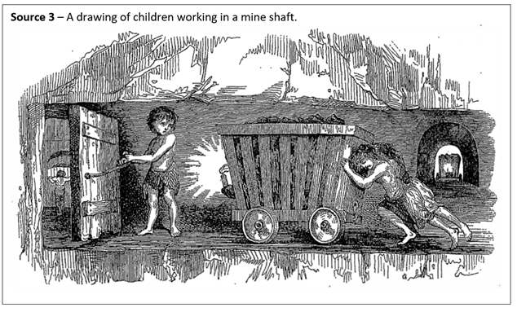Pressure to change these conditions came from a variety of groups in society:

* evangelical churchmen who felt it their Christian duty to look after the weaker people in society
* rich landowners who resented the new wealthy industrialists
* industrialists themselves who wanted to stop unscrupulous use of cheap labour by their competitors.

A series of bills that passed between 1830 and 1867 gradually led to some regulation of the industry, although the hours worked and the conditions of work were still harsh by today’s standards. Some of the most important of these were:

* The Factory Act of 1833, which set legal limits to the working hours of children and was enforced by the appointment of factory inspectors
* The Mines Act of 1842, which banned the employment of women and under-age children in the mines.
* The Ten Hours Bill of 1847, which limited the time worked by women and children in factories to ten hours a day. Because women and children were essential for the running of the machines, it effectively meant that a man’s work day was also limited to ten hours.

A series of bills were passed to improve the conditions of children working as chimney sweeps; but because the business was so profitable, these were not enforced and it was not until 1867 that effective legislation was passed.

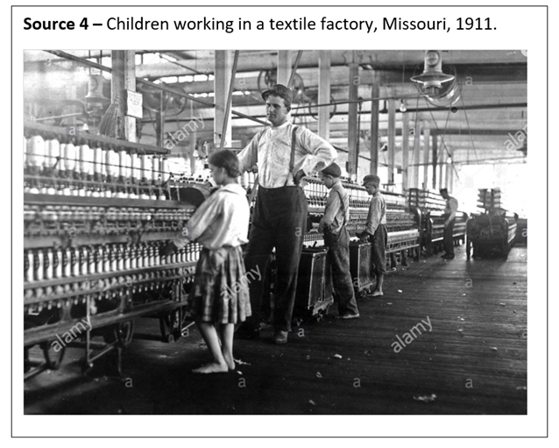

Source 5 – A historian describes how chimney sweeps were employed.

The very poorest London parents found they could apprentice a child to a chimney sweep much younger than any other occupation. More than this, no apprentice fee was expected, and the master sweep was even ready to pay a sum to the parents for the service of the child, who was thus literally bought and sold. “It was a common practice”, said David Porter, a remarkable master chimney sweeper, “for parents to carry about their children to the master chimney sweepers and dispose of them to the best bidder, as they cannot put them to any other master at so early an age.” (Dorothy George, from England in Transition, Penguin, 1964, pp.123-4.)**

# Analysing a Visual Source

Child labour was common during the Industrial Revolution, with many children working up to 16 hours a day.

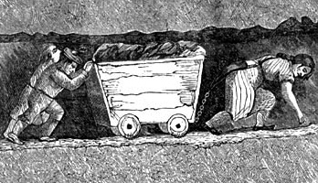

► A hurrier and two thrusters heaving a corf (a basket or small wagon) full of coal, as depicted in the 1853 book The White Slaves of England by J Cobden

# Working Conditions in Industrial Revolution

## Working Conditions in Factories

* **Long working hours** - normal shifts were usually 12-14 hours a day, with extra time required during busy periods. Workers were often required to clean their machines during their mealtimes.

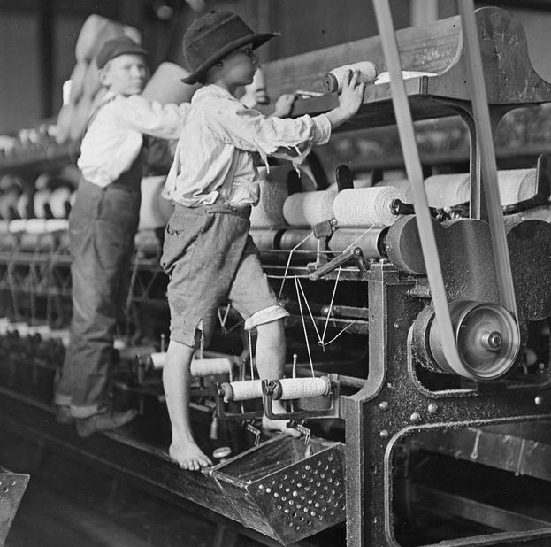

|583x578

* **Low wages** - a typical wage for male workers was about 15 shillings (75p) a week, but women and children were paid much less, with women earning seven shillings (35p) and children three shillings (15p). For this reason, employers preferred to employ women and children. Many men were sacked when they reached adulthood; then they had to be supported by their wives and children.
* **Cruel discipline** - there was frequent strapping (hitting with a leather strap). Other punishments included hanging iron weights around children’s necks, hanging them from the roof in baskets, nailing children’s ears to the table, and dowsing them in water butts to keep them awake.
* **Fierce systems of fines** - these were imposed for talking or whistling, leaving the room without permission, or having a little dirt on a machine. It was claimed that employers altered the time on the clocks to make their workers late so that they could fine them. Some employers demanded that their overseers raise a minimum amount each week from fines.
* **Accidents** - forcing children to crawl into dangerous, unguarded machinery led to many accidents. Up to 40 per cent of accident cases at Manchester Infirmary in 1833 were factory accidents.
* **Health** - cotton thread had to be spun in damp, warm conditions. Going straight out into the cold night air led to many cases of pneumonia. The air was full of dust, which led to chest and lung diseases and loud noise made by machines damaged workers’ hearing.
* **Parish apprentices** - orphans from workhouses in southern England were apprenticed to factory owners, supposedly to learn the textiles trade. They worked 12-hour shifts, and slept in barracks attached to the factory in beds just vacated by children about to start the next shift.

From https://www.bbc.co.uk/bitesize/guides/zkxrxyc/revision/2

# Experiences of Ordinary Men, Women and Children

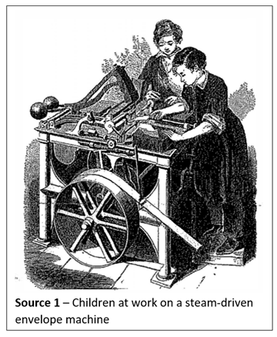

## Life in England

For the millions of people who left their country villages to come to the city, the Industrial Revolution seemed to promise good work and a good wage. In many cases, these hopes were quickly dashed. For most, work in this new world meant very long hours in dangerous conditions for inadequate pay. For others, the new cities offered only unemployment and poverty.

## The Industrial City

The Industrial Revolution created large cities and towns, in which the living conditions for ordinary people were very poor. The need to accommodate all of the new workers in the factories forced the rapid construction of cheap housing resulting in new suburbs of extremely poor quality. Government officials noticed these problems, and frequently sent observers to report on living conditions.

### Factories

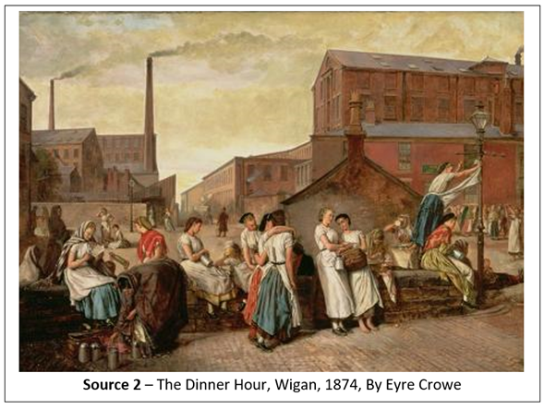

|583x438

The new factories seemed enormous compared with the small workshops people were used to. We can see how they looked from the paintings of Eyre Crowe (see Source 2), who went to Wigan to study the people who worked in them.

This scene accurately shows known buildings such as the Victoria Mills, at the left of the scene, owned by the industrialist Thomas Taylor. Artists often sold their paintings to wealthy industrialists, who expected them to be accurate. The painting still has some limitations as a source for the historian. It only shows the factory girls resting, not working. They are taking a meal break, and seem happy and relaxed. They are well dressed, only one is barefoot, and clean and healthy.

A policeman patrols the street behind them, suggesting that everything is in order. The painter might have depicted a very different scene if he had gone inside the factory.

In most factories, people worked long hours and received low pay. If the workers demanded better wages, the owners dismissed them and took on other desperately poor workers instead. Moreover, the factory you see probably lacked safety equipment. The industrialists argued that safety equipment cost money but made no profits, so there was no point buying it. In the cotton mills, for example, young women like those in the painting worked for years in a factory where the air was full of fine cotton dust. When they breathed it in, it filled their lungs, causing lung disease and finally death. It was possible to buy large extractor fans to remove the cotton dust, but many industrialists argued that it was cheaper to hire new workers to replace those who died.

### Child Labour

One of the worst problems in the new factory was the use of child labour. By law, a child was not allowed to work until the age of six, but few factory owners obeyed this rule.

Once they were employed, children worked very long hours. Those who fell asleep were whipped by their employers to stay awake; some were so exhausted they fell forward into the working machinery and were killed. In some factories, children were employed to use their small hands to clean out the machines while they were still operating, and many were injured when their hands got caught in the moving parts.

Warning Voices

Some of the strongest warning voices of the Industrial Revolution came from the industrialists themselves. Many were businessmen who believed that making profits was the only thing that mattered.

They thought social problems only occurred because working people were lazy or drunk. Others saw the truth. The Industrial Revolution itself was creating bad working conditions, low pay, bad housing, poverty and unemployment.

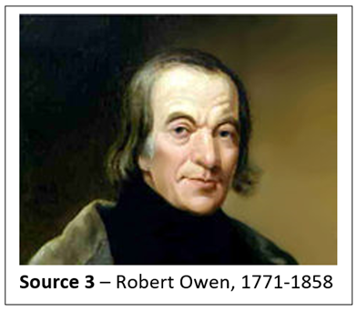

Robert Owen was a rare industrialist who bravely stated that bad working conditions were the main cause of the dirt, violence and crime in the industrial cities. He suggested that if owners improved the conditions in the factories, workers would also improve their behaviour.

To prove his point, he built a mill at New Lanark, near Glasgow in Scotland. He paid for large windows to let in light and air, plus proper toilets, drainage and even baths. He cut down working hours. He made sure that workers had free time, and encouraged them to read or to exercise during that time. He refused to employ children under the age of 10. He hoped that industrialists would see his successful factory and copy his reforms. When that did not happen, he went straight to the English parliament and persuaded Sir Robert Peel, the then Prime Minister, to pass laws to improve conditions in factories. He even showed working men how to form a trade union. He was so committed to reform that he spent his fortune on ideas to improve the lives of working people.

Workers often had to work long hours, in dangerous conditions, for a wage that was hardly enough to live on. Sometimes workers tried to go on strike, refusing to work until they were given better wages. The employers fought back by dismissals (getting rid of workers), lock-outs (shutting down their factories for a time) and importing labour (getting other workers from areas where there was unemployment). The workers fought back by forming trade unions, in which all members of a trade promised to strike together and support each other.

|  |
| --- |
| Times Gone By . . . . .In 1848, after revolutions had swept European countries such as France and Germany, the English novelist Elizabeth Gaskell decided to explain why she had written her novel Mary Barton (1848), with its sad and often alarming descriptions of the hardships of working-class life. She finishes by warning that if something was not done to help the workers, England might experience a revolution in the same way that France did.I had always felt a deep sympathy with the care-worn men, who looked as if doomed to struggle through their lives going between work and poverty. A little expression of my sympathy, and the expression of the feelings of some of the working people who I knew, led them to lay their hearts open to me. I saw that they were sore and irritable against the rich. Whether the neglect which they experienced from the wealthy - especially from the masters whose fortunes they had helped to build - were fair is not for me to judge. This belief turns to revenge in too many of the poor uneducated factory-workers of Manchester. Whatever public effort can do in the way of laws, or private effort in the way of kind deeds, should be done as soon as possible. My view of the state of feeling among too many of the factory people in Manchester has received some confirmation from the events that have recently occurred among the workers of Europe.Source 4 – This text has been abbreviated and simplified for younger readers. Gaskell’s complete text may be found in Mary Barton (Oxford: Oxford University Press, 1980, pp. xxxv-xxxvl). |

|  |
| --- |
| Betty Harris, age 37:I was married at 23, and went into a colliery when I was married. I used to weave when about 12 years old; can neither read nor write. I work for Andrew Knowles, of Little Bolton (Lanes), and make sometimes 7s (shillings) a week, sometimes not so much. I am a drawer (moving coal carts in the mine), and work from 6 in the morning to 6 at night. Stop about an hour at noon to eat my dinner; have bread and butter for dinner; I get no drink. I have two children, but they are too young to work. I worked at drawing when I was in the family way. I know a woman who has gone home and washed herself, taken to her bed, delivered of a child, and gone to work again under the week.I have a belt round my waist, and a chain passing between my legs, and I go on my hands and feet. The road is very steep, and we have to hold by a rope; and when there is no rope, by anything we can catch hold of. There are six women and about six boys and girls in the pit I work in; it is very hard work for a woman. The pit is very wet where I work, and the water comes over our clog-tops always, and I have seen it up to my thighs; it rains in at the roof terribly. My clothes are wet through almost all day long. I never was ill in my life, but when I was lying in.My cousin looks after my children in the daytime. I am very tired when I get home at night; I fall asleep sometimes before I get washed. I am not so strong as I was, and cannot stand my work so well as I used to. I have drawn till I have bathe skin off me; the belt and chain is worse when we are in the family way. My feller (husband) has beaten me many a times for not being ready. I were not used to it at first, and he had little patience.Source 5 – A woman miner’s evidence included in the Parliamentary Report on English Female miners, Great Britain. Parliamentary Papers. 1842 |
| ![ |

|  |
| --- |
| ELIZABETH BENTLEY, CALLED IN; AND EXAMINED.What age are you? – Twenty-three.Where do you live? – At Leeds.What time did you begin to work at a factory? – When I was six years old.At whose factory did you work? – Mr. Busk’s.What kind of mill is it? – A flax mill.What was your business in that mill? – I was a little doffer. (Doffers tied up full spindles of linen on looms and replaced them with an empty spindle.)What were your hours of labour in that mill? – From 5 in the morning till 9 at night, when they were thronged.For how long a time together have you worked that excessive length of time? – For about half a year.What were your usual hours when you were not so thronged? – From 6 in the morning till 7 at night.What time was allowed for your meals? – Forty minutes at noon.Had you any time to get your breakfast or drinking? – No, we got it as we could.And when your work was bad, you had hardly any time to eat it at all? – No; we were obliged to leave it or take it home, and when we did not take it, ’the overlooker took it, and gave it to his pigs.Do you consider doffing a laborious employment? – Yes.Explain what it is you had to do? – When the frames are full, they have to stop the frames, and take the flyers off, and take the full bobbins off and carry them to the roller; and then put empty ones on and set the frame going again.Does that keep you constantly on your feet? – Yes, there are so many frames, and they run so quick.Your labour is very excessive? – Yes; you have not time for anything.Suppose you flagged (slowed down) a little, or were late, what would they do? – Strap us.Are they in the habit of strapping those who are last in doffing? – Yes.Constantly? – Yes.Girls as well as boys? – Yes.Have you ever been `1strapped? – Yes.Severely? – Yes.Could you eat your food well in that factory? – No, indeed I had not much to eat, and the little I had I could not eat it, my appetite was so poor, and being covered with dust; and it was no use to take it home, I could not eat it, and the overlooker took it, and gave it to the pigs.You are speaking of the breakfast? – Yes.How far had you to go for dinner? – We could not go home to dinner.Where did you dine? – In the mill.Did you live far from the mill? – Yes, two miles.Had you a clock? – No, we had not.Supposing you had not been in time enough in the morning at these mills, what would have been the consequence? – We should have been quartered.What do you mean by that? – If we were a quarter of an hour too late, they would take off half an hour; we only got a penny an hour, and they would take a halfpenny more.The fine was much more considerable than the loss of time? – Yes.Were you also beaten for being too late? – No, I was never beaten myself, I have seen the boys beaten for being too late.Were you generally there in time? – Yes; my mother had been up at 4 o’clock in the morning, and at 2 o’clock in the morning; the colliers used to go to their work about 3 or 4 o’clock, and when she heard them stirring she has got up out of her warm bed, and gone out and asked them the time; and I have sometimes been at Hunslet Car at 2 o’clock in the morning, when it was streaming down with rain, and we have had to stay until the mill was opened.SOURCE 1 – Evidence given before the Sadler Committee. Great Britain, Parliamentary Papers, 1831-32. Vol. XV p115 |

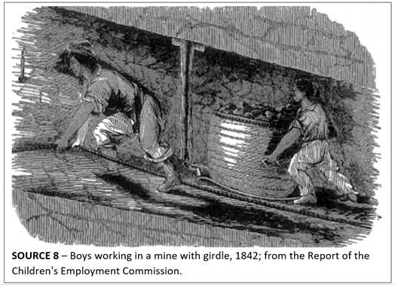

## What Were the Short-term and Long-term Impacts of the Industrial Revolution?

As we have seen, the Industrial Revolution had many appalling short-term impacts. These included the exploitation of labour, grinding poverty and environmental damage. In the long term, the Industrial Revolution increased standards of living in the Western world and provided the infrastructure for modern urban society. It also facilitated globalisation. This involved the rise of international trade-the movement of goods and capital-and the more rapid spread of ideas through new forms of communication. Globalisation, however, had a negative side. It eroded some cultures, and was part and parcel of cultural imperialism. This is related to empire building.

## Global Changes in Landscapes, Transport and Communication

The Industrial Revolution not only changed the way goods were manufactured but also led to changes in the way land was used, as well as changes to transport and communication. Railways, steamships and the telegraph became commonplace.

# Convicts, Free Settlers and Slaves

## Transportation and Migration

The Enclosure Acts and the Industrial Revolution drove country people to the cities in the search for new forms of work. The population of Britain grew and the cities became more crowded. Conditions in the city deteriorated as streets were filled with garbage and sewage, and disease spread. The difference between the lives of the privileged rich and the despairing poor was probably greater at this time than any other period in British history. Approximately one-tenth of the English population, and one-quarter of the Irish population, were destitute.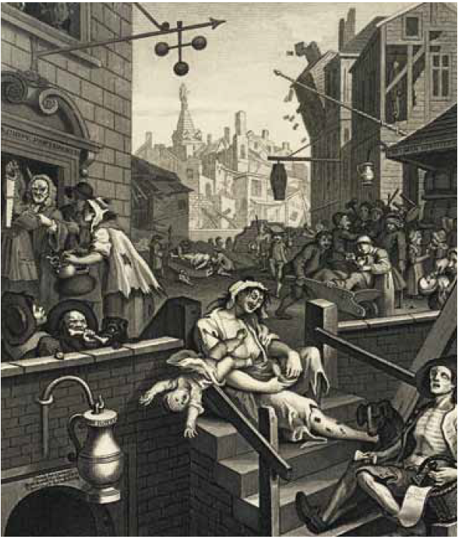

Children as young as six years of age mined the coal that was driving the engines of the Industrial Revolution and worked the factory mills that produced the cloth. Children continued to toil in the British mines until 1860.

Source 1 The 1751 painting Gin Lane by William Hogarth showed the violence and poverty of life in the streets of the late eighteenth-century slums of England’s cities.

## Convict Transportation

Without jobs and a future many people turned to crime. Their choice was between stealing or starving. At this time there was no organised police force and no real way of managing the serious social problems of eighteenth and nineteenth-century Britain. The British government responded to the crime wave by sentencing more criminals to death. Executions were carried out in public to act as a reminder to criminals of what would become of them if caught. By the early nineteenth century there were 200 different crimes punishable by death.

The other major form of punishment was transportation. Most of the convicts were people who had been found guilty of theft. After being sentenced to transportation, prisoners were chained in rat-infested convict ships, called hulks, until space was available on seaworthy transport vessels that would carry them across the globe.

During most of the eighteenth century, prisoners were usually transported to the Americas. The British government sold their convict labour to the American planters as a punishment, which also earned Britain money. The use of this criminal workforce in the Americas was disrupted by the revolution of 1776. Britain’s crushing defeat in the American War of Independence brought an end to North America as Britain’s criminal dumping ground.

The British government began a plan to ship her criminals to West Africa. Many were transported in leg irons on slave ships, bound for Africa’s coastal slave forts. Convicts were sent to West Africa to then work as convict-soldiers, assigned to guard captive Africans waiting to be sold into slavery. In 1781 murder and mutiny destroyed Britain’s West African plan for her banished criminals. The British government then decided to transport her convicts to the distant shores of the great south land, Australia.

## Free Settlers — Migration to Australia

The hardships of Industrial Revolution Britain created crime and a constant supply of convicts for transportation to Australia. It also created a large number of potential migrants. Hardship pushed people to look to the world beyond for the opportunity to build a better way of life. The government of the penal colony encouraged free settlers to make the long journey halfway around the world. Within five years, free settlers were arriving in the colony. They were given land grants by the governor and the use of convict labour to farm their properties. Between 1830 and 1850 over 200 000 people made the journey to Australia. They came of their own choice, and they came to stay.

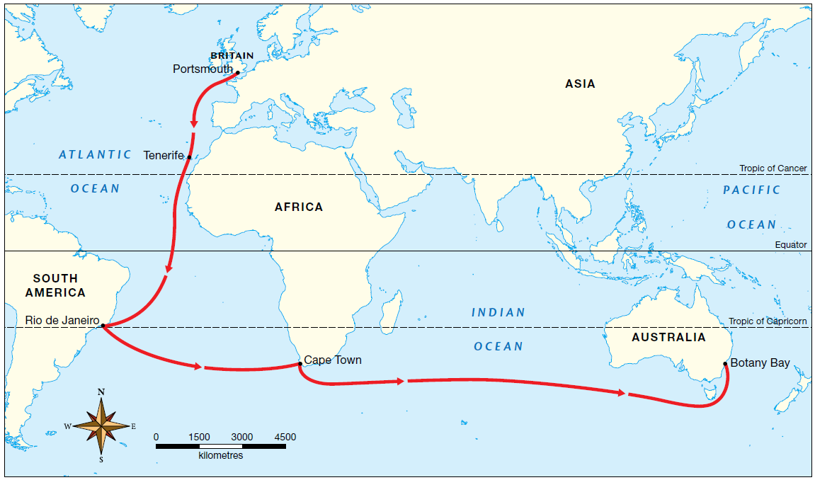

Source 2 Map showing the route taken by the First Fleet. The fleet of 11 ships departed from Portsmouth, England on 13 May 1787. The ships sailed into Botany Bay on 18 January 1788, before arriving at Sydney Cove on 26 January 1788.

|  |
| --- |
| That the skilful farmer would be enabled to obtain an independent and comfortable subsistence is, however, indubitable; and the larger his family, provided they were of sufficient age to afford him an effectual co-operation, the greater would be his chance of a successful establishment. Hundreds of this laborious class of people, who in spite of unremitting toil and frugality, find themselves every day getting behind-hand with the world, would undoubtedly better their condition by emigrating to this colony, if there were only a probability that they would be enabled to go on from day to day as they are doing here. In this country they are at best but tenants of the soil they cultivate; whereas there they would be proprietors, and the mere advance which would be taking place in the value of their farms, would before many years not only render them independent but even wealthy … For the artisan and mechanic, who are skilled in the works of utility, rather than luxury, there is, as it has been already remarked, no part of the world, perhaps, which affords an equal chance of success. To any, therefore, who have the means of transporting themselves and families to this colony, the removal would be in the highest degree advantageous. They could not fail to find immediate employment, and receive a more liberal return for their labour, than they would be able to procure elsewhere. The blacksmith, carpenter, cooper, stone-mason, brick-layer, brick-maker, wheel and plough-wright, harness-maker, tanner, shoe-maker, taylor, cabinet-maker, ship-wright, sawyer, &c. &c. would very soon become independent, if they possessed sufficient prudence to save the money which they would earn. The advantages, however, which the colony offers to this class of emigrants, great as they undoubtedly are, when considered in an isolated point of view, are absolutely of no weight when placed in the balance of comparison against those which it offers to the capitalist, who has the means to embark largely in the breeding of fine woolled sheep. Source 3 In 1819 the explorer and politician W.C. Wentworth wrote a book about the colony. In his book he set out his vision of Australia and the opportunities offered to free settlers in the new land. |

## The Slave Trade

Sixteenth-century Europe established a global trade network. This international trade made it possible for valuable products such as maize, sugar, silver, coffee, tobacco and cotton to be purchased in European marketplaces. Europeans were at the centre of this world trade because they built great ocean-going fleets of trade ships, and they controlled the vast plantations and mines producing these valuable goods.

The Spanish were the first Europeans to take land in the Americas for mining and farming. Sugar was in great demand in Europe and so planters established vast holdings in the Caribbean and South America. Plantation work was long and hard. Native Americans died in their millions from the unhealthy conditions they worked under, and from the effects of the diseases spread by the European settlers. The Spanish and Portuguese colonists looked for alternative sources of labour and found African slaves who could meet the demands of American agriculture and mining. The slave trade to the Americas was pioneered by the Portuguese who used African slaves on their plantations in the Cape Verde Islands, off the coast of west Africa, and in the Madeira Islands located in the Atlantic. The British soon joined the slave trade because of the huge profits that could be made.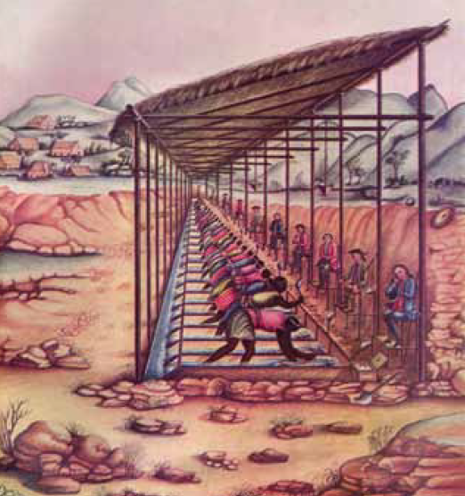

By the eighteenth century the cheap labour provided by millions of African slaves was allowing Europeans to prosper. Slave traders were among the richest people in eighteenth-century Britain.

Source 4 Slaves working in diamond mining in Brazil

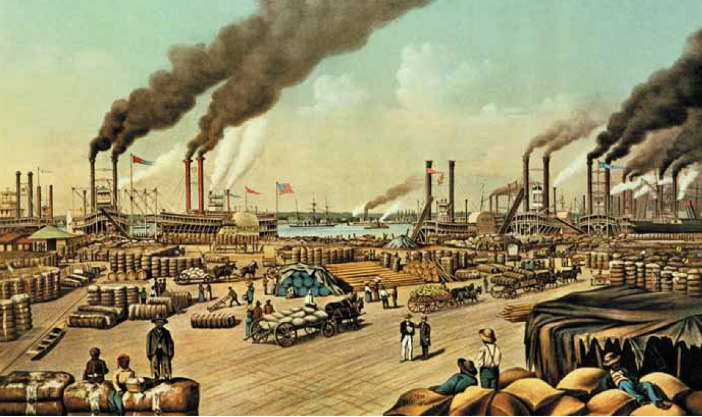Source 5 Cotton produced by slaves on the plantations of North America was loaded onto ships for transport to the cotton mills of Europe.

## The Triangular Trade

As the numbers of European settlers across the Americas steadily increased, the ‘Triangular Trade’ developed (see source 6). Ships laden with European goods sailed to Africa, collected a cargo of slaves and then sailed back to Europe with valuable American trade goods such as sugar and cotton. The Atlantic crossing between Africa and the Americas was called the Middle Passage.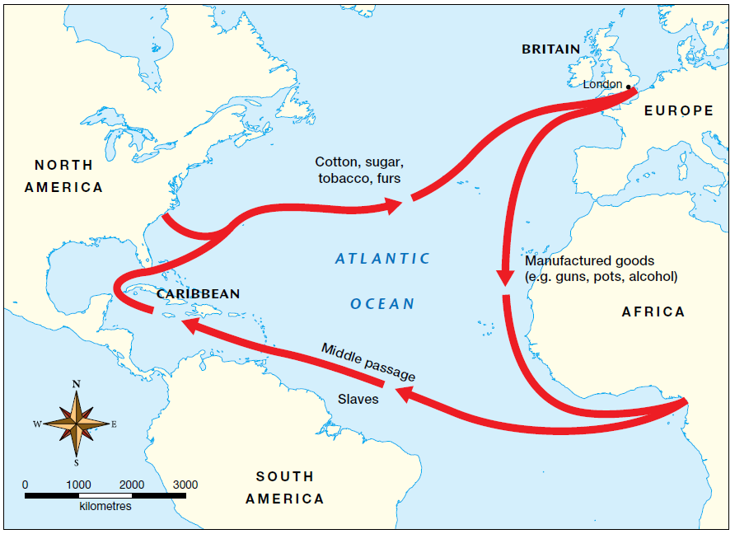

Source 6 Map showing the movement of slaves out of Africa

## Slaves to Industry

The wealth from the slavery of the American plantations helped to build the Industrial Revolution in Great Britain. Much of the British technology that changed the world was developed from the profits made by slave traders. At the beginning of the nineteenth century, the British government received millions of pounds in revenue from the slave trade, and the taxes and duties that accompanied it.

The goods produced by approximately six million slaves working the fertile soils of America, Cuba and Brazil continued to stimulate the commercial growth of Europe. By the end of the eighteenth century, approximately 60 thousand slaves were transported each year to the Americas. Two and a half million slaves were employed at any one time in the production of sugar, tobacco and cotton.

Technology developed in the Industrial Revolution made slave labour even more productive:

The development of the steam engine increased the efficiency of sugar plantations in Cuba, as horses were replaced by machinery. The sugar mills operated non-stop, and were worked by slaves on 18-hour shifts.

In 1807 the British Parliament passed an act making it illegal for British ships to carry slaves, or for British colonies to import slaves. Despite the abolition of slavery, the profits from the trade continued to flow into the marketplaces of Britain. The southern states of America depended on the wealth that came from slave labour for their development, and refused to abolish the slave trade. Spain and Portugal also refused to abolish slavery and so the trade continued until the end of the nineteenth century.

Slaves bought in Africa produced sugar on plantations in the Caribbean that fed people in Europe, including by the eighteenth century workers who were making England’s industrial revolution and providing goods that people across the world wanted to buy.

English planters made their fortunes in the colonies and then returned to Britain and a life of luxury:

* William Beckford was a plantation owner in Jamaica. Upon his return to Britain he became the Lord Mayor of London, known for his lavish dinner parties.
* Famous businesses such as Barclays Bank and The Phoenix Insurance Company were established from profits from slave plantations.
* Britain’s Prime Minister Gladstone invested the wealth made from his plantations to build his trade empire, which included the Liverpool to Manchester railway.
* London slave traders invested their fortunes in the newly developing industries, such as the manufacturing of textiles. During this period the city of Manchester became known as Cottonopolis, the city of cotton, because of the huge quantity of fabric manufacturing.

Source: Oxford Insight History, Stage 5, 2nd edition, 2021

# Free Settlers to the New World

Unlike the convicts and slaves, free settlers moved willingly to start new lives. During the eighteenth and nineteenth centuries, North America, Australia, New Zealand and South Africa were seen as offering abundant land, although no consideration was given for the displacement of Indigenous peoples. In some cases, free grants of land were made. Even when land was not free, prices were usually low, and this was possibly the greatest factor that pulled new immigrants towards these places. The discovery of gold in North America and Australia also led to a dramatic shift in population. In 1750, Europe’s population was 163 million, and it grew to 408 million by 1900. Over the same period, North America’s population rose rapidly from 2 million to 82 million.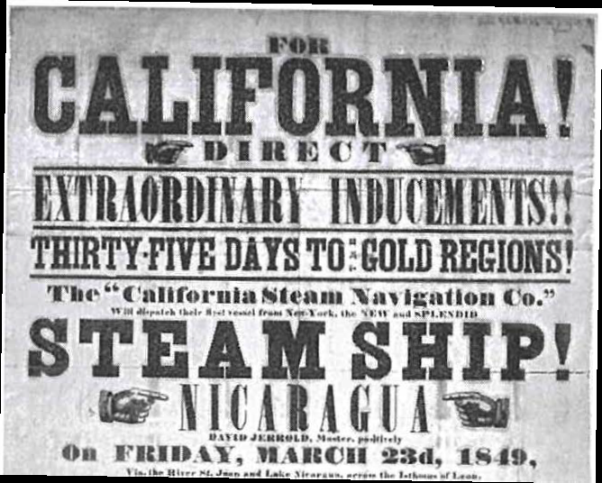

Source 1 An advertisement for transport to the California goldfields, 1849

## North America

The British colonies in what we now know as the United States of America fought a war in the eighteenth century (the American War of Independence) to break free of British control. The chance to be a part of a new nation was a powerful ‘pull’ factor in drawing new immigrants. It led to a period of European expansion, as people moved west across the country, developing new settlements and trade routes. All these changes created more employment and opportunities for Europeans to own land. By the late nineteenth century, Canada, also a British colony, was starting to open up. Like the United States, it had large areas of land available. To encourage development of the west, land was given free to European settlers along the route of the Canadian Pacific Railway.

In 1848, gold was discovered in California, sparking the first gold rush. People from around the world went to the west coast of North America seeking instant wealth, and settled in the new territories (which were not yet part of the United States). Around 300 000 people arrived in California over the next five years, transforming the area. This was followed by a Colorado gold rush in 1859, causing the population of the western region of North America to grow rapidly. A couple of smaller gold rushes also hit Canada around this time, ending with the big Klondike gold rush in the Yukon in 1897.

Because of these gold rushes, North America became known as a land of opportunity. The idea of a prosperous democracy was a powerful ‘pull’ factor for many Europeans, who had seen their lives become worse during the changes of the Industrial Revolution.

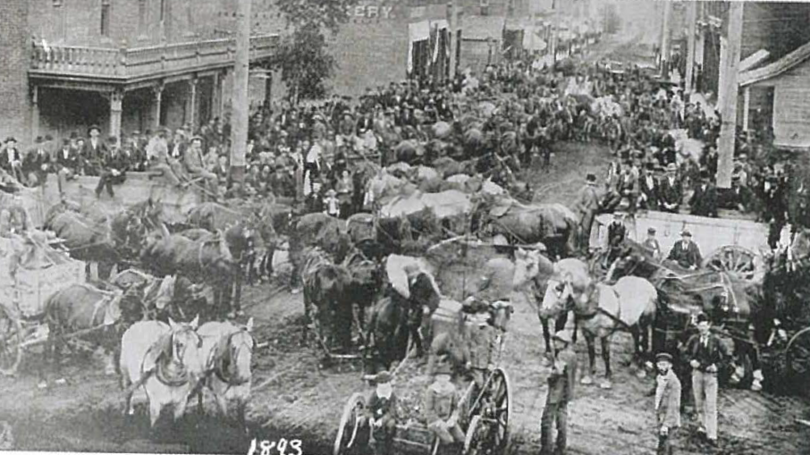Source 2 A photograph from the nineteenth century shows a street scene in Idaho Springs, Colorado, as goldminers flocked to the area.

## Australian Colonies

By the 1820s, although convicts and former convicts still made up the largest segment of the population of Australia, there were growing numbers of free settlers arriving. The need for workers had increased as land exploration opened up the continent.

Some settlers were part of a new group of ‘assisted migrants’, whereby employers could apply for financial assistance to bring workers to Australia if they had a particular skill that was needed. This approach would also be used to boost immigrant numbers in the twentieth century.

As in the United States, the discovery of gold helped transform Australia. In 1848, mineralogist William Tipple Smith discovered gold near Bathurst in New South Wales, and the gold rush began in 1851. Between 1850 and 1860 the population of Australia almost tripled, from 405 400 to 1 145 600.

Among those who came to Australia during the gold rush era were a second wave of Chartists and other political refugees. There was a perception that, in Australia, there was  a greater opportunity to think and speak freely, practise one’s chosen religion and express differing political views. Many stayed to become settlers in the new nation that would emerge with Federation in 1901.

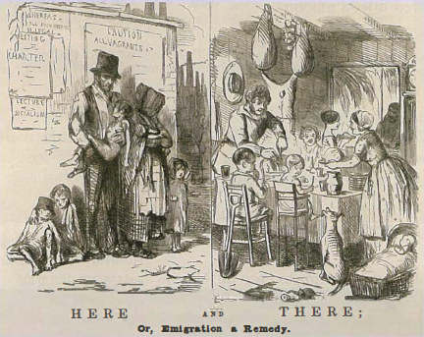

Source 3 One of many posters used in Britain during the nineteenth century to encourage European people to emigrate to the New World

Source: Oxford Insight History, Stage 5, 2nd edition, 2021

# Connection between The Industrial Revolution and Convicts, Free Settlers and Slaves

|  |  |
| --- | --- |
| Type of settler | Example points |
| Convicts | - Poverty, poor living conditions and high crime rate led to a large number of convicts. - They were sold to American plantations which made money for Britain. - After the US war of independence, they were sent to West Africa to act as soldiers to guard the African slaves. |
| Free Settlers | - Free settlers were encouraged by the governments of the new land by the awarding of land grants. - The harsh living conditions of industrial revolution Britain encouraged large numbers of people to want to relocate to new countries like Australia because of the opportunities they offered. - The new settlements also needed to benefit from those skilled in new technologies. |
| Slaves | - Many industries and businesses in the industrial revolution were founded on money earnt from the slave trade. - Slaves were used as cheap labour for production during the industrial revolution. - Technology developed in the Industrial Revolution made slave labour even more productive: The development of the steam engine increased the efficiency of sugar plantations in Cuba, as horses were replaced by machinery. The sugar mills operated non-stop, and were worked by slaves on 18-hour shifts. |

# Convict Transportation from Britain

As we have learnt, growing populations across Europe, and the movement of people from rural villages to rapidly developing towns and cities, resulted in a massive increase in crime rates in Britain during the seventeenth and eighteenth centuries. There was serious competition for available jobs, housing, food and services (such as access to doctors). For some, petty crime was an easy way to earn a living, while for others it was a necessity - a case of steal or starve. Most criminals were poor, unskilled and uneducated. There was little understanding of rehabilitation, so the only response to this growth in criminal activity was punishment. In the late eighteenth century, at least 200 crimes were punishable by execution, including murder, treason and theft of valuable goods.

Those who escaped the death penalty were imprisoned in overcrowded jails, where conditions were far worse than even the poorest slums. When jails became so overcrowded that they could not hold any more prisoners, a new solution had to be found. Rather than building new prisons, criminals were imprisoned on ships that were no longer considered seaworthy. These ‘hulks’, as they were known, were moored in British harbours and filled with so many prisoners that they were even more cramped and unhealthy than the jails (see Source 1). It was also more difficult to make them secure, so riots and escapes were a constant problem.

In eighteenth-century Britain, new theories for treating and dealing with criminals became popular. One theory in particular was widely supported - that crimes could be stopped by the removal of the ‘criminal class’ from the wider population. In line with this theory, convicts were first sent to British colonies in North America, such as Virginia and

Maryland. This continued until Britain lost control of these colonies in 1783, after the American War of Independence. It was at this time that Joseph Banks, the botanist who had sailed with James Cook to Australia and the South Pacific in 1770, suggested Botany Bay on the coast of New South Wales as a good location for a new penal colony.

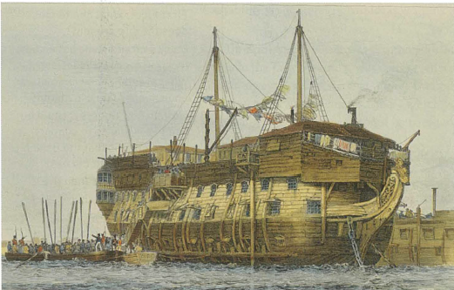

Source 1 An artist’s impression of prisoners being rowed out to a hulk, 1829

*STRANGE BUT TRUE*

Examples of people who were executed in the late eighteenth century include an admiral killed by firing squad for ‘not doing his utmost’ in a battle; one man burned at the stake for forgery; and another hanged for ’playing cards with a forged ace of spades·.

## The Penal Colony of New South Wales

The First Fleet of ships left Britain carrying over 700 convicts on the six-month journey to New South Wales in 1787 (see Source 6). Arriving at Botany Bay on 18 January 1788, it soon became clear that the area was unsuitable for colonisation, so the fleet moved on to Port Jackson (Sydney Harbour), landing at Sydney Cove on 26 January 1788.

## Other Penal Colonies

Other penal colonies in Australia were later established in Tasmania, at Port Phillip in Victoria, on the Swan River in Western Australia, at Moreton Bay in Queensland, and on Norfolk Island. For more than 80 years, convicts and ex-convicts provided the labour force that helped to develop these Australian colonies by building roads and houses, and clearing dense forests.

## Political Prisoners

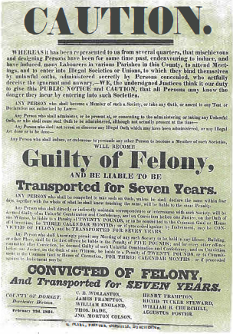

|304x435

A significant category of convicts transported to Australia was made up of political prisoners. These were people who had criticised the king or opposed the authority of the government in some way. Workers who formed the first trade unions were among those sent to the colonies. One such group - six agricultural labourers from the English village of Tolpuddle had set up a union to bargain for wages with local landowners.

They were convicted in 1834 of ‘swearing a secret oath’ and transported to Australia for seven years. However, the men became popular heroes, and only two years into their sentence they were pardoned and returned to England. For their sacrifice, they earned the title the ‘Tolpuddle Martyrs’.

Source 2 Detail from a public poster that cautioned against attending or joining unions

Other political prisoners included:

* **Luddites**
* **Chartists**, who were linked to trade unions and who proposed a People’s Charter to give all men the vote and to stop the wealthy from dominating the political process. Chartists played a crucial role in the development of representative democracy in the Australian colonies.

Who were the convicts?

The story of Australia’s convict past has often been contested by different historians, academics and everyday people, largely as a result of our uneasy relationship with how it defines us as a country today. This contestability is the result of two ideas working against each other:

* **The desire to forget or cover up the past** - Up until the 1960s, it was common for Australians with transported convict ancestors to hide the fact, because it was considered a stain on the family name. South Australia has always emphasised that, unlike the rest of Australia, it was settled as a free colony; while Van Diemen’s Land - which was established as a place to send the most hardened convicts - changed its name to Tasmania in 1856 to remove the association with its past.
* **The desire to mythologise or romanticise the past** - To this day, it is common for certain convicts and settlers from Australia’s past to be singled out and held up as examples of people who triumphed over adversity, such as Francis Greenway (a convicted forger who went on to become Australia’s first government architect) and Isaac Nichols (a convicted thief who later set up Australia’s first post office).

Historians have differing views of the convicts and the kind of people that they were. Some argue that political prisoners protesting against corruption and unfair government policies were not criminals at all, and that the law-breakers who did commit crimes were merely the victims of poverty and harsh laws. Other historians suggest that the convicts were, in reality, hardtflened criminals, and that half to two-thirds of them were repeat offenders who chose a life of crime even though other work was available.

The most common offences that resulted in transportation to Australia after 1788 included pick-pocketing, sheep- and horse-stealing, highway robbery and burglary. Many convicts were from newly industrialised cities, and research has shown that 40 per cent of the convicts transported to Australia in the First and Second Fleets came from the London area. Not all those convicted of a crime were transported. Generally, transportation was reserved for those under 50 years of age who had been convicted more than once. Statistics show that, until 1851, around 30 per cent of the convicts were under 19 years of age.

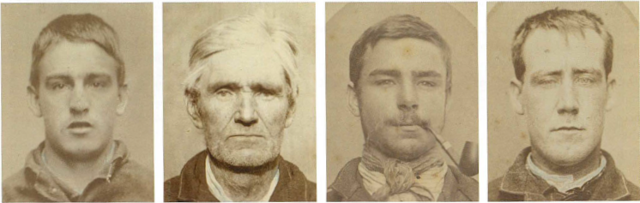Source 3 Photographic portraits of convicts taken after their arrival in Australia

Source: Oxford Insight History, Stage 5, 2nd edition, 2021

# Impacts of European Settlement on Aboriginal People

## Impact on the Eora People of Sydney

The founding of the convict settlement of Sydney directly resulted in the dispossession of Aboriginal people. Over 30 separate Aboriginal clans had lived in the Sydney region for at least 40 000 years. One of these clans, the Gadigal people, came from the south shore of Sydney Harbour, in the area from Watsons Bay to Sydney Cove. It was the Gadigal people who witnessed the 1788 arrival of the First Fleet at Sydney Cove.

The arrival of the British began the process that saw the Gadigal lose their lands and their self-sufficient, hunting and gathering way of life. The Gadigal and other coastal Aboriginal people in this area were known as the Eora. They lived well on the harbour’s fish, oysters, mussels and cockles. The foreshores provided plenty of vegetables, grubs, possums, wombats and kangaroos. The arrival of the British brought competition for clean water and food, and introduced fatal European diseases. The new arrivals cut down trees, desecrated sacred sites, stole Aboriginal spears and fishing lines, polluted waterholes and rapidly extended their control of the land.

Governor Arthur Phillip was under British orders to establish good relations with the indigenous people, so he commanded that ‘the natives should not be offended or molested on any account’. The Eora shouted ‘Wona worra’, meaning ‘Go away’, but then extended hospitality to the newcomers. The first exchanges between Eora and Europeans on the beaches of Sydney were friendly; beads, mirrors, cloth and gestures of goodwill were exchanged. The newcomers and the traditional owners of the land laughed, joked and danced together.

|  |
| --- |
| Tuesday 29 January 1788 - Landed on a point forming the NW or middle branch to which we were followed by several of the natives along the rocks, having only their sticks which they use in throwing the lance with them. A man followed at some distance with a bundle of lances; they pointed with their sticks to the best landing place and met us in the most cheerful manner, shouting and dancing. The women kept at a distance near the man with the spears. This mark of attention to the women, in showing us that although they met us unarmed they had arms ready to protect them, increased my favourable opinion of them very much. A.M. Went over to Shell Cove and left this branch, taking it as reported by those who examined it when the boats first came into this harbour. As we left this branch we met several canoes with one man in each of them; they had so much confidence in us as to come close alongside our boats. After fixing the place of the rock and extent of the shoalwater round it we went into the north arm. As we were going into the first cove on the east side called Spring Cove, we were joined by three canoes with one man in each. They hauled their canoes up and met us on the beach leaving their spears in the canoes. We were soon joined by a dozen of these and found three amongst them with trinkets &c. hanging about them that had been given to them a week before by the governor on his first visit to this place. Our people and these mixed together and were quite sociable, dancing and otherwise amusing them. One of our people combed their hair withwhich they were much pleased; several women appeared at a distance, but we could not prevail on the men to bring them near us. We had here an opportunity of examining their canoes and weapons: the canoe is made of the bark taken off a large tree of the length they want to make the canoe, which is gathered up at each end and secured by a lashing of strong vine which runs amongst the underbrush. One was secured by a small line . . . . The governor’s plan with respect to the natives was, if possible, to cultivate an acquaintance with them without their having an idea of our great superiority over them, that their confidence and friendship might be more firmly fixed. We could not persuade any of them to go away in the boat with us. SOURCE 1 Account of the first British impressions of the Eora by William Bradley, first Lieutenant on the Sirius. |

Behind British goodwill was the clear intention to establish a British prison on Aboriginal land. Within a week of arrival, the British had cleared trees, built the Governor’s small cottage and planted a vegetable garden. By 1790 the Eora had names for the uninvited visitors - Berewalgal - people from a distant land. The early attempts at establishing friendly relationships began to fail when the clash over land and culture began.

### A Battle for Survival

The sudden arrival of over 1000 Berewalgal, who did not respect traditional land boundaries and claimed all the Eora land for themselves, placed a huge burden on the limited resources of the area. By the first winter of 1788 the Eora communities were beginning to experience hardship and hunger as the colonists took the best land and the Eora were forced onto the lands of neighbouring clans to hunt and gather food. The battle for survival had begun.

|  |
| --- |
| In December 1788 a group of convicts reported a hostile encounter with a large band of warriors. Governor Phillip feared that relations with the Eora were steadily deteriorating and decided that communication had to be established. The new strategy was to kidnap Eora men, teach them English and send them back to their communities as goodwill ambassadors. Twelve days later an Eora man, Arabanoo, was kidnapped from Manly Beach. He quickly learnt to speak English but died within a year from the smallpox epidemic, called gal-gal-Ja by the Eora. |

### The Spread of Disease

Smallpox spread rapidly and devastated the Eora people. Convict work gangs reported seeing the effects of the disease in April, 1789. Bodies covered in sores were being found in caves or lying unattended at abandoned camp sites. In May, Captain John Hunter noted the absence of the usual signs of Eora daily life around Sydney Cove. Arabanoo, an Eora man who had been taken captive and learned to speak English, was taken down to the harbour to make contact with his family. He found no-one. According to the eyewitness report of David Collins:

|  |
| --- |
| ‘… not a living person was anywhere to be met with. It seemed as in flying from contagion they had left the dead to bury the dead. He lifted up his hands and eyes in silent agony for some time; at last he exclaimed ’All dead! All dead!’ and then hung his head in mournful silence’. |

Arabanoo and the colony surgeon nursed the Eora brought to a camp hospital set up to treat the smallpox victims. Arabanoo caught smallpox from his patients and died on 18 May 1789.

The origin of the disease remains uncertain. An Aboriginal smallpox-marked face was not seen at the time of the first European settlement; and yet during the second half of 1789, the terrible path of the disease could be traced right across Port Jackson, Broken Bay and the Hawkesbury regions. There were no recorded cases of smallpox outbreaks on the First Fleet ships. Some suggested it had come from Macassan fishermen to Australia’s north. Others suggested that it had come as smallpox scabs left stuck to the blankets and old clothing given as gifts to the Eora. Whatever the source of the disease, the impact on Aboriginal people was catastrophic. In just over a year, well over half the Eora people of the Sydney region were dead.

|  |
| --- |
| I herd the crying of children close to me - I asked them for to goe and bring me there (Dins) which is there woman and I would give there woman Some bits of different coulerd cloath which I had brought on purpose to give to them - they made me to understand that there were no women there … Dourrawan went and brought a Boy about 3 Years old on his Shoulder - the child was as much frightend at use as Davis was at them - I then desired Tirriwan to goe and bring me down one of his children as Dourrawan informd me that he was the father of the Child he had brought down and that his woman the mother of his child was (poc) dead of the (mittayon) Small Pox - Tirriwan brought also down a Boy much a bout the same age as the other - Tirriwan child was not quite Recoverd from the Small Pox - I asked him for his (din) he Said that She was up in the wood given a Young child the (nipan) the Breast - I gave each of the children a bit of Red cloath - I asked them if they would give me the children for my hatt which they Seemd to wish most for but they would not on any account part with there children which I liked them for - SOURCE 2 Lieutenant Ralph Clark’s account of his meeting with the Eora, whose community was being devastated by the outbreak of smallpox |

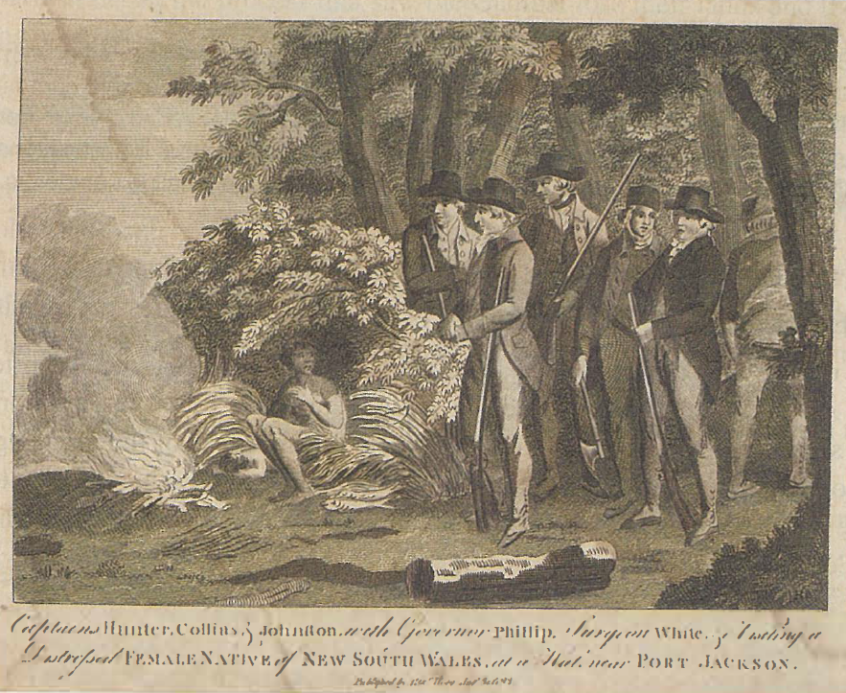

SOURCE 3 Engraving by Michael Adams, 1793. The Aboriginal woman in the image is suffering from smallpox and is shown being given assistance by the colonists.

|  |
| --- |
| [Arabanoo’s] countenance [face] was thoughtful, but not animated; his fidelity [loyalty] and gratitude, particularly to his friend the governor, were constant and undeviating, and deserve to be recorded. Although of a gentle and placable temper, we early discovered that he was impatient of indignity, and allowed no superiority on our part. He knew that he was in our power; but the independence of his mind never forsook him. . . .Extract from W. Tench, Complete Account of the Settlement at Port Jackson, London, 1793, p. 10. SOURCE 4 A personal account of the character of Arabanoo, as recorded by the marine captain of the First Fleet, Watkin Tench |

## European Settlement Expands

As the quantity of harbour fish dwindled and as vegetable supplies were eaten out, the colonists began to hunt and fish in the lands beyond their immediate settlement. The rapid expansion of European settlement continued after the departure of Governor Phillip in 1792, to the land that stretched from Sydney to the foot of the Blue Mountains. This was the land of the Dharug people. The lagoons and creeks of the Hawkesbury-Nepean River and the open grasslands of the plains provided the Dharug with their source of life and culture. The Dharug required a large enough area in which to move about, hunting kangaroos, possums, fish and other animals, and gathering seasonal food such as yams. When the British cleared the land for agriculture, housing and industry, the loss of traditional Aboriginal food sources was complete.

By the 1810s the plains of Sydney had become overcrowded. With the crossing of the Blue Mountains in 1813, the search for more pastoral land pushed the frontier of European colonisation into the north-west of New South Wales. European settlement spread into the land of the Kamilaroi, Muruwari and Wailwan people. Along the traditional paths of communication between Aboriginal communities, word spread of the pale strangers who came on unusual beasts.

The British government continued to give land grants to settlers and to big pastoral companies, because sheep farming and wool made huge profits. By 1824, it was clear to the Kamilaroi people of northern New South Wales that the European settlers intended to:

* take possession of the land
* deny Aboriginal people access to the waterholes
* destroy traditional hunting and gathering grounds
* disregard traditional law and sacred sites.

## Losing the Land

The nineteenth-century experience of the Eora and the Kamilaroi peoples was repeated across the continent. The Kamilaroi people were given no compensation or payment for the 223 000 hectares of their land taken by the Australian Agricultural Company in the 1830s. The Kamilaroi were allowed to stay on their land only if employed by the company as stockmen or as domestic servants.

By 1860, the European settlement covered over 400 million hectares of Aboriginal land. As immigrant populations expanded across Australia, Aboriginal people were increasingly left on the outskirts of settlement.

Many Aboriginal people worked on pastoral properties or took refuge on reserves and missions, which were places established for religious conversion or social improvement. European missionaries were inspired to bring Christianity to the Aboriginal people on the missions. They aimed to save the souls of the Aboriginal people by turning them away from their languages and cultural practices. The missions did provide people with basic health and educational services, and some protection from the cruelty and exploitation of the towns and large pastoral properties.

Between 1860 and 1910, laws were passed to ‘protect’ and separate Aboriginal people from the European population. Aboriginal people were forced from their traditional land and onto the reserves and missions. In New South Wales, the Aborigines Protection Board was established in 1883 to implement the government policy that all ‘full-blood’ Aboriginal people should live on the 25 New South Wales reserves.

People were encouraged to establish farms on the reserves so that they could become self-sufficient. However, the reserves were located away from towns and on areas of land too small to allow Aboriginal communities to support themselves.

|  |
| --- |
| It was the loss of the land which was worst … The land itself was now disfigured and desecrated, studded with huts, crossed by tracks and fences, eaten thin by strange animals, dirtied and spoiled, and guarded from its owners by irresistible and terrifying weapons. The all-embracing net of life and spirit which had held land, and people, and all things together was in tatters. The sustaining ceremonies could not be held, men and women could not visit their own birthplaces or carry out their duties to the spirits …- Judith Wright, The Cry for the Dead, Oxford University Press, Melbourne, 1981, p. 27. SOURCE 5 Australian poet Judith Wright, in The Cry for the Dead (1981 ), wrote about the despair of Aboriginal communities experiencing the loss of their land. |

Source: Retroactive 2, Stage 5 History, NSW, 2014

# The Experiences of Slaves

Slaves were kidnapped from the north-west coast of Africa - from places such as Guinea (a French colony) or Gold Coast (a British colony). Slave catchers used rope nets to capture young Africans. Often, they were captured while they were out hunting, and their families would never have known what happened to them. They were herded into cages and then loaded onto slave ships.

The conditions under which slaves were shipped to the Americas were brutal. The quarters for the slaves below the decks were little more than leaking, ocean-going dungeons. In summer, the heat was stifling. In winter, the slaves - with little clothing and no blankets or bedding - would shiver with cold. It was almost impossible for slaves to find a comfortable position because of overcrowding and the fact that they were in chains. Much of the time, they were forced to lie in their own urine and excrement. The only relief might come when small groups were allowed briefly on deck, while still in chains, to be hosed down with sea water.

The slaves were fed the bare minimum of food required to keep them alive, in order to reduce costs and maximise profits. They also had only limited access to fresh water.

Many slaves attempted escape during the journey, or tried to end their misery by jumping overboard. Some also refused to eat. Slave-ship captains responded by ordering crew

members to smash the teeth of those troublesome slaves, and force-feed them. Slavers also used a special tool, like a pair of pliers, called the speculum oris. The pointed ends were jabbed

between the jaws of the unfortunate slave and then, with the turn of a screw, the ends opened and forced their jaws apart, sometimes breaking their teeth.

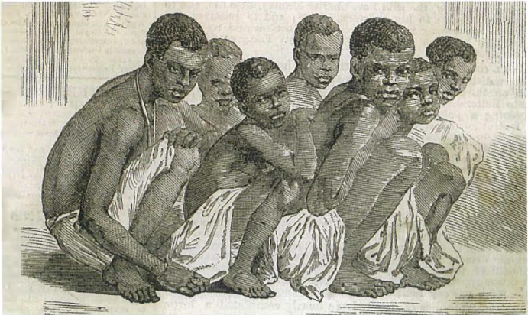

Source 1 An illustration from The Illustrated London News, 20 June 1857, shows how slaves were packed together on board slave ships. They were often forced into painful postures, with barely enough room to turn.

It was common for rebellious slaves to have their hands cut off, and then their heads. The severed body parts were then passed around to other slaves below deck as a warning. For some African tribes, the severing of their heads was the worst imaginable fate, as they believed that without their heads, their spirits would never find their way home. In one terrible case, a newborn baby - whose slave mother had died in childbirth on a slave ship - was left out in the sun to die, and later thrown overboard. The captain was found not guilty of murder because there had been no ‘premeditated malice’. The court ruled that he had not planned for the woman to die, and that without a mother the child would have died anyway.

## Transportation of Slaves

|  |
| --- |
| I was soon put down under the decks, and there I received such a greeting in my nostrils as I had never experienced in my life; so that, with the loathsomeness of the stench, and crying together, I became so sick and low that I was not able to eat, nor had I the least desire to taste anything. I now wished for the last friend, death, to relieve me; but soon, to my grief, two of the white men offered me eatables; and, on my refusing to eat, one of them held me fast by the hands, and laid me across, I think, the windlass, and tied my feet, while the other flogged me severely . . . The white people looked and acted, as I thought, in so savage a manner; for I had never seen among my people such instances of brutal cruelty . . . The closeness of the place, and the heat of the climate, added to the number in the ship, which was so crowded that each had scarcely room to turn himself, almost suffocated us . . . The air soon became unfit for respiration, from a variety of loathsome smells, and brought on a sickness among the slaves, of which many died . . . This wretched situation was again aggravated by the . . .  chains, now . . .  unsupportable, and the filth of the necessary tubs, into which the children often fell, and were almost suffocated. The shrieks of the women, and the groans of the dying, rendered the whole a scene of horror almost inconceivable. Source 2 Extract from the autobiography of Olaudah Equiano, who was captured and sold as a slave in Benin; he wrote about his experiences in The Interesting Narrative of the Life of Olaudah Equiano, or Gustavus Vassa, the African, published in 1789 |



Source 3 A steel slave whip used in the nineteenth century on ships transporting slaves

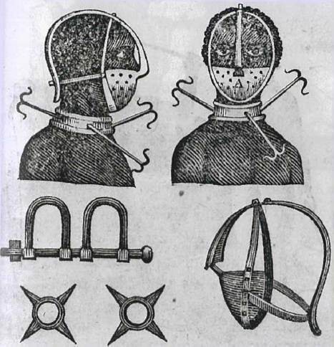

Source 4 The various forms of restraint used for slaves. The three metal prongs around the neck ensured that if a slave managed to escape, he could not lie down.

## Arrival in the Americas

When the slave ships docked at one of the American ports, the slaves were unloaded and prepared for auction. Sores and wounds were covered with tar to make them less visible, and troublesome slaves were given laudanum (made from opium) to sedate them. The slaves were paraded like animals before the interested buyers. Potential purchasers would examine them thoroughly, look in their mouths, feel their muscles, and even comment on their ability as potential breeders of more slaves. The entire process was dehumanising and undignified, and the slaves had no idea where they were or what was ahead of them.

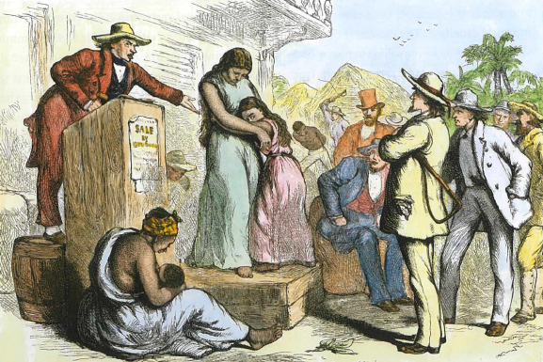

Source 5 A coloured engraving depicting a slave auction in America’s Deep South, c. 1850

The experiences of African slaves in the Americas varied according to when they were transported, what skills or physical attributes they had, where they were sent, and who bought them. The majority of slaves brought to the southern states of North America and the West Indies worked on plantations and farms. They were given new names, and usually went by the surnames of their masters. They worked long hours in the cotton, sugar or tobacco fields, and lived in simple huts with few comforts. Slaves also worked in the house, and tended animals and vegetable patches. Female slaves were often at the mercy of male members of the household, and the illegitimate children of these masters were also born into slavery.

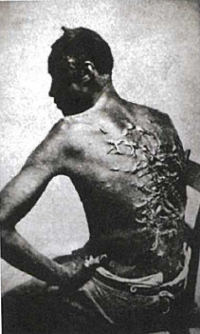

Slaves who tried to escape were severely punished. Whipping was common for those who were caught, and repeat offenders could have their teeth filed into points so that it was obvious to all that this slave was troublesome.

Source 6 The scarred back of a slave - the result of a brutal series of whippings

Under American law slaves were always considered to be property, not human beings.

For example:

* Under the law, slaves could be bought and sold by their owners, and separated from their families.
* Slaves were not allowed to own property of their own, and were not allowed to leave their master’s land without permission.
* Laws were passed that made it illegal for slaves to learn to read or write.
* Slaves were not allowed to be out after dark or join with groups of other slaves, except for supervised work or church.
* Slaves were never allowed to hit or challenge a white person, but a white person could kill a slave while punishing them without breaking the law.
* The slave owners attempted to wipe out any memory the slaves had of their African heritage.

There were exceptions, however. Some slave owners taught their slaves to read and write (because it benefited them to do so). There were also slave owners who would never sell or separate families, and others who set their slaves free when the slaves reached retirement age. Many slaves managed to preserve memories of their African heritage, parts of their traditional languages and stories from their past. The music they brought with them from Africa would also survive and become a major contributor to twentieth-century American culture.

In the twenty-first century, an ongoing debate in American society and politics regarding reparations (payment of compensation) for the injustices of slavery has continued to divide Americans. This is important, as much of the American economic system and wealth was built by slaves who never got to share this wealth. Also, many slaves made great inventions throughout this period that became the property of and were patented by their owners, whose wealth was further increased at the expense of the slaves.

These patents are still held by slave owners’ families, and reparation has not been made to the descendants of the slaves.



Source 9 Black American music has made a major contribution to twentieth century American culture.

Source: Oxford Insight History, Stage 5, 2nd edition, 2021

# The Translatlantic Slave Trade

Slavery is as old as human history. It was a feature of life in the ancient world, and also a feature of African history even before the arrival of the Europeans. Traditionally, African tribal leaders made slaves of their captured enemies, although they stayed in their own country and could buy their way out of slavery.

From the 1600s onwards, the European powers began to exploit African resources. This meant looking to Africa for trade goods, territory, and human cargo in the form of slaves. During the 1700s, Britain became a major player in the trade that had previously been dominated by the Portuguese and the Spanish. Britain’s participation in the slave trade was driven by the profit motive - merchants were happy because their ships were full (and thus earning money) on each of the three legs of the triangular trade route. At the end of each leg, merchants’ profits increased. The slaves they captured in Africa were sold for profit in the Americas, and raw materials such as sugar, tobacco and, later, cotton were taken on board. These were then shipped to Europe for sale. In Europe, cheap manufactured goods were loaded on board and carried back to Africa for sale at a profit.

The pursuit of profit, along with a sense of European superiority, ensured that the slave trade grew rapidly. It lasted until 1833 in the British Empire and until 1863 in the United States.

By the end of the eighteenth century, up to 12 million Africans had been taken as slaves to the West Indies, South America and Britain’s American colonies. The size of the slave trade was not just the result of the desire for cheap labour, as the number of sugar, tobacco and cotton plantations increased in the Americas. It was also due to the high premature death rate among slaves. This meant that more slaves were always needed to maintain the size of the workforce.

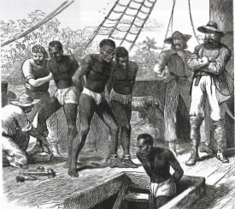

Source 1 Shackled slaves being put in the hold of a slave ship bound for the Americas.

Unlike convicts, who could have opportunities in a new land after completing their sentences, slaves had very little to look forward to. Slavery usually lasted for life, and a slave’s children were born into slavery. These children were often the result of European sexual abuse of women in slavery.

## Transportation of Slaves

Perhaps the most notorious leg of the transatlantic slave trade was the ‘middle passage’. This was the section of the journey in which slaves were transported from Africa, across the Atlantic Ocean, to the Americas. The journey lasted anywhere from one to six months.

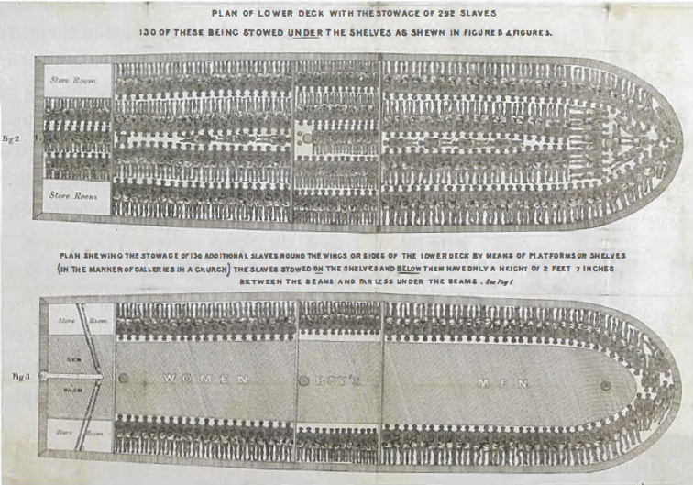Source 2 A plan of the British slave ship Brookes in 1789, showing how 454 slaves were loaded in accordance with the ‘tight pack’ method following the Slave Regulation Act of 1788. Before the Act, the ’tight pack· method would have meant the ship carried up to 740 slaves.

Slaves were packed below deck, often in chains, where they were forced to lie side by side in cramped conditions with little headroom. Slave ship companies went to great lengths to find the best way of ‘packing’ their human cargo for shipment. In terms of their business model, the ‘best way’ was of course the most profitable way, but there was debate about how they could achieve this. Some favoured the ‘loose pack’ method, arguing that by giving slaves a little more room, not as many would die from the appalling conditions.

Those slaves who did survive the ‘loose pack’ would also arrive in better condition and fetch a higher price at the slave markets. Others favoured the ‘tight pack’ method, with many more slaves loaded onto a single ship. It was argued that even if some died or reached the Americas in poor health, there would still be more slaves to sell. ‘Tight pack’ was generally more popular, on the basis of profits. Of course, it did not take into account the price of human suffering.

Source: Oxford Insight History, Stage 5, 2016

# The Lives of Free Settlers in Australia

Settlers, squatters and selectors

Early settlers in Australia came in search of a better life, or to make their fortune. Some settlers had agricultural backgrounds, but others, such as the military officers who were given large land grants, had no farming experience.

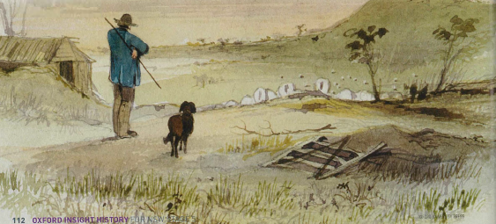

Squatters were settlers who cleared stretches of Crown land and occupied them with their sheep and cattle, without official ownership. They lived on the frontiers, far away from government regulation and supplies. Squatters were often the first Europeans to explore parts of inland Australia, and chose the most fertile land to settle on. The government later

gave licences to squatters, allowing them to lease the land they already occupied. Some squatters became very wealthy and were the pioneers of Australia’s wool industry.

In the 1860s, the governments of the Australian colonies dispossessed Aboriginal people and sold blocks of land that they had previously leased to squatters. The new settlers who bought small areas of land to farm were known as selectors. Wealthy squatters purchased most of the fertile land they had cleared and worked, and selectors were often left with the poorest farming land without easy access to water.

The life of settlers in Australia could be harsh. Even with the help of convict labour and Aboriginal people who may have been able to stay on their traditional lands in return for unpaid work, it could take years to clear their land of trees, and establish their crops and livestock. Food was scarce, and settlers initially lived in basic bark shelters, or built ‘wattle and daub’ huts made of tree branches and clay.

The lives of early Australian settlers

Source 1

[T]he selector’s … stock of ready money is usually exhausted by the time he has ringed and felled a few trees upon the site of his future homestead, erected a hut of slabs and bark, furnished it with a trestle bed and blankets, a rudely-constructed table and bench, a few cooking utensils, an axe, a spade, a crosscut saw, and a supply of flour, tea and sugar … and when he has broken up a few perches of land and put in his first crop, he is not unfrequently compelled to seek for work in the neighbourhood at fencing or road-making, in order to maintain himself until the ‘kindly earth’ shall have yielded him her increase [produce a crop] … In some cases the free-selector, who is fortunate enough to be the possessor of a horse and to be quick and dextrous [skilled] in the use of the shears, sets out in the beginning of August for the woolsheds in the south of Queensland, or in the north of New South Wales, to fulfil a yearly engagement at sheep-shearing … returning in time to gather in his own crops, and with cheques in his pocket representing at least a hundred pounds … He is thus enabled to purchase a few head of stock or a better description of plough, to build a more commodious [spacious] hut, and to supply the wife and children, for whom he has been making a home in the bush, with such articles of wearing apparel [clothes] as they may stand in need. There is plenty of hard work and very little recreation in such a life …

Descriptive sketch of Victoria c. 1860, in Picturesque Atlas of Australasia, 1886

Source 2

Each stockman’s hut stood by itself in a clearing, leagues distant [miles away] from any other dwelling, and as far as might be from the nearest scrub, in the thickets of which the Blacks could always find an unassailable stronghold.

The settler depended for safety upon the keenness of his hearing, the excellence of his carbine [rifle], and the Blacks’ superstitious dread of darkness, which makes them averse to leaving their camp except on moonlight nights, or with an illumination of burning firesticks.

Extract from Rosa Praed, Australian Life: Black and White, Chapman and Hall, 1885

Source 3

Then there was a garden, fenced in with hurdles, over which our tame kangaroo took his daily constitutional [walk]; but nothing grew in it except pumpkins and fat-hen [a type of weed]. Well for us that they did flourish, for we lived on pumpkins and mutton for three months, during which time the drays were delayed by flooded creeks, and the store was empty of flour, tea, sugar, and all other groceries.

Description of life on Naraigin, a sheep station 300 kilometres from Brisbane, c. 1850s, in Rosa Praed, Australian Life: Black and White, Chapman and Hall, 1885

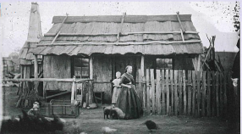

Source 4 A settler family’s bark house c. 1870, New South Wales

## The Gold Rush in Australia

The discovery of gold in 1848 at a sawmill in California sparked a gold rush that led to the spectacular growth of the west coast of the United States. As people flooded to the goldfields, San Francisco was transformed from a city of 1000 people in 1848 to more than 25 000 people by the end of 1849.

Edward Hargraves was one of the hopefuls who had travelled there. He was unsuccessful at finding his fortune in California; however, after returning to Australia he took advantage of the New South Wales Government’s failure to acknowledge William Tipple Smith’s 1848 find near Bathurst, west of Sydney, and claimed in 1851 that he had discovered gold in the same area. This well-publicised ‘discovery’ sparked the gold rush in Australia.

Living conditions were hard for everyone on the Australian goldfields. In places such as Bendigo, for example, around 40 000 people lived close together in tents. Water and fresh food were scarce. Garbage piled up around the diggings, and toilets were simply holes dug in the ground. The unsanitary conditions and poor diet led to diseases such as dysentery and typhoid. Most ‘diggers’ worked from dawn until dusk, six days a week.

It is estimated that more than 80 per cent of the population on goldfields were male, as women generally remained at home with their children. Some women did brave the difficult conditions to keep the family together, but they risked death or disease from the lack of sanitation and medical care. Children under the age of five made up the majority of deaths on the goldfields.

In the early years of the gold rush, most miners were able to make reasonable returns, and ‘alluvial gold’, which washed up in creek and river beds, was relatively easy to find. By the 1850s, however, much of the alluvial gold had already been found, and miners had to dig mine shafts to find veins of ‘reef gold’, which occurred many metres underground.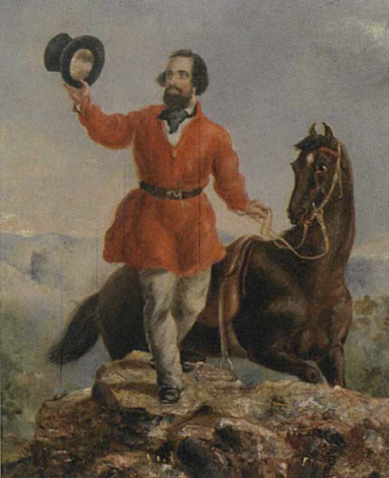

All miners had to pay a licence fee, which was bitterly resented. It became one of the factors that contributed to the Eureka Rebellion in 1854.

Source 5 Mr E.H. Hargraves, the Gold Discoverer of Australia, 12 February 1851, Returning the Salute of the Gold Miners, by T.T. Balcombe [1851]; paintings like this one helped to create the legend of Hargraves as the discoverer of gold in Australia.